V o n R u n n e

V o n R ö n n/ e / n

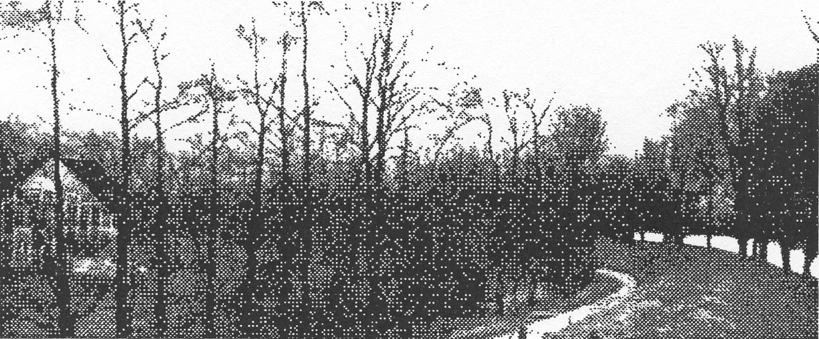

“This and That”

Personal and other’s
Heritage

“This and That”

Personal and other’s Heritage

of family members

Year 1004 Was the “Runneborg” an ancestral castle of the family?
1257 Were the Weser river marshes, the ancient homeland of “Knight van Runne”?
1475 Otto von Rönne’s purchase agreement of inheritable succession
1560 Gerd van Rönne as “Squire of Osten”
1617 Barthold von Rönne donates a clock for the church in Osten
1641 From the marriage contract of Captain Gerd von Rönne
1650 Johann, the last judge is deposed
17th Century, Main estate in Altendorf—Dike Law is the same
1689 Dike law comparison, due to “Altendorf Sea dikes”
17th Century, Eastward of the Elbe (St. A. Rostock)
17th Century Marriage or Cloister—“Rönnes” daughters listed
1709 Carl Ewald von Rönne, Baron and Russian General
1756 Sale of Altendorf estate to the Schlichting brothers
1766 Letter of Christian Wilhelm von Rönne from Loxstedt
1777 From the life of surveyor Christian Wilhelm von Rönne
1793 The “Rönner Stone” near Witsum on the “Island of Föhr”
1798 Friedrich L. von Rönne
1804 Ludwig P. M. von Rönne, judge and professor of jurisprudence
1830 The “von Rönne” from Rönnschleus
1843 Dedication for clarification, from fairy-tale author Wilhelm Grimm
1871 Emigrants to the U. S. A.
1855/88 The wind millers in Cadenberge and Osterholz/Scharmbeck
1915 Edmund Carl, the first Rönne to own a car
1917 Imperial sponsorship for Friedrich Wilhelm von Rönne
1991 Several “von Rönn and von Rönne” of today’s populace
1926/30 Book of residents of the counties Hadeln, Kehdinger and Neuhaus
1992/93 Today’s “von Rönn/e/n” from official telephone books noted

Year 1004 Was “Runneborg” an ancestral castle?

In the year 1004, this Rönneberg in the south of Hamburg was mentioned already in early documents. It had, with certainty, existed at the time of Emperor Charlemagne (circa 800) and was located as a palisade fortress above the Elbe lowlands and overlooking a passage (ferry) over the Elbe at Over. At the beginning of the 13th Century (before that date?) was “back of the castle” a place built subject to rent to the Counts of Wölpe. According to documents from 1233-1242, the Wölpes paid the “Tenth” to the monastery Walsrode. In the nearness of the Wölpe castle by Nienburb on the Weser River, there was, according to Hoyer U. B., at this time, a residence “Runne” at Marklode, which, however, about 1300, already was in the ownership of the Bremen Lords von Tiesenhausen.

Year 1257 Were the Weser Marshes the ancient homeland of “Knight van Runne”?
The custodian of the archives for the jurisdiction Bruchhausen/Wilsen, Herman Bornbusch, wrote in a 1257 document and others, that:
“Heinricus et Ludolfus dei gratia Comites in Aldenborch frates…Datum in castro nosstro Brochusen Anno Domini 1257.

According to the Saxon law entitlement, the younger Count Ludoph took over the regency of county Aldenburg (county Bruchhausen was not conveyed). This Ludopf had Countess Hedwig von Wölpe for a spouse. That is why, later, the county Wölpe came under Aldenburg, which their grandson Otto von (now!) Oldenburg was sold in 1302 to Duke Otto von Braunschweig/Lüneburg (a flower of speech)

Successor of Count Ludolf was his son Count Hillebold, which, authentically, is proved 22 times; and, indeed, 10 x as von Aldenburg, 6 x as Oldenburg, 4 x as Bruchhausen and 2 x uncertain. He was married with Countess Sophie von Lecklenburg. With him went the old county Aldenburg, lost in 1301, with which the Counts Gerhard and Otto von Hoya were vested now in 1302 with fiefdom from Duke Otto von Braunschweig/Lüneburg.

However, a vestige of Aldenburg had remained to the Aldenburg counts by the Bremen Archbishopric to the tenure of the next successor. With this was the Lord Hildebold von Bruchhauser, who was married with Countess Sophie von Ravensberg, vested by the Archbishopric. Count Hildebold is authenticated 3 time, and on October 12, 1304 one could read in a Bremen document:

“Junker (squire) Hildeboldus de Brochhusen dei gratia Comes de Oldenborch”.

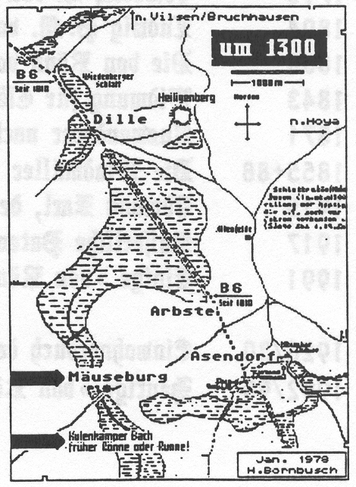
His son Otto confirmed this investiture on May 18, 1336. It is from 1321-1360 13 times evidenced, mostly as Count Otto von Bruchhausen and Oldenburg. After his and his mate’s deaths, the land grant descended by marriage according to an agreement to the Counts of Hoya. However, already before this, on June 29, 1358, both Counts Gerhard and Johann went by the names of Hoya and Oldenburg.

From here on, can one well follow, that, circa 1300, the appearance of “de Runne” was the original vassals of the Aldenburg counts and that their residence was this Mäusburg on der Rönne (or Runne).
See sketch on the right margin.

Herman Bornbusch says also, that “this town locale” westward from Hoya around 800 was a great fortification area with Vilsen as middle point; that Widukind’s son Wigbet, circa 850, finished.One named this castle after his wife Altburg, later an Aldenburg, after which from the middle of the 12th century, the here named counts were residents.
NOTE FROM THE TRANSLATOR: We, of the extended von Ronne family, owe our deepest gratitude to Gerhard von Rönn of Hambur-Harburg, Germany, the author of this chronicle, and his son Jörg of Schleswig, Germany, without whose help we would have been unable to express in American English the contents of these four following pages, VR 055 through 058. For us, Gerhard graciously translated the ancient dialect into modern German. Then Jörg summarized, with familial zeal, in American English in order that we might better understand the finer nuances of our heritage.

Year 1475—OTTO von RÖNNE’S Inheritance letter

I, Otto van deme Rönne, knight in the Holy See of Bremen, a monastic in the parish of Osten, with this document, declare to all people who can read, hear and write, that I of my own free will and forethought, as attested by this document, for my rightful heirs and with the full agreement of my wife, Mette, have sold the piece of land prescribed below to Herr Hinrike Jercke, pastor at Osten and his successors to come, in perpetuity, for,

18 Lübsche Mark to be paid to me immediately
as well as in each year thereafter in perpetuity 1 Punt of money at Easter time.
This same Punt of money had belonged to the aforementioned Metter, my wife. Should she outlive me, Otte the aforementioned, she shall, because the land was sold apart from Otto’s estate, house and fields, have again the 18 Lübsche Mark as a widow’s annuity from the land where she now lives and that she and their children should write and consider that the land had previously belonged to Johann Sogen (Mette’s father), which prescribed piece of land is prescribed as follows: to the west up to the Wedergemut; toward Osten up to the Wegekreuzung and begins on the way and goes to the south up to Qürgraben and, at the time, at the back is the cabbage land of Gert Sogen. This land now belongs to pastor Hinrick Jercke.
The specified Punt of money is clear and free and shall yet for dike, dams, slues, culverts, graves and water courses be valid, or both. The liabilities and encumbrances, be as they be, especially anyone’s claims and legal actions, are assumed by Herr Hinrick, he and the pastors succeeding him. So have I, Otto, Sekemolde, Johann, my son and my rightful heirs read and discussed, and I, Erick as counsel, Otto, and Hinrick Düreyar, a monastic at Stade, Medelover and our rightful heirs read and discussed this document of intention and will, do solemnly vow and say by this letter that we before all men will execute the trust of this prescribed annuity and will defend against claims and hindrances, when, who, where, as voluminous as they may become; or in the case heirs become illegal or admonished.
Furthermore, have I, Otto, and my honorably named son Johann, and my rightful heirs said, that this annuity as an eternal inherited income is valid. Also if there were documents with other evidence dü to the Punt of money, such should have no power; also as if everyone should be deceased.
All these detailed items, articles and subjects have, I, Otto, my son Johann, Sahemolde, Erick, Hinrick, all named witness and heirs vowed to hold forever secure and unbroken, against various annoyances or evil defamation, whereby one as a result of this document, may become offended either spirit wise or secular wise. So have I Otto, Johann, my son, Erick and aforementioned Hinrick, Sakemolde and Medelovers, for us and our rightfully designated heirs, confirmed all our rightful attestations by this document.

_________________________________________________________________________________________

Written according to Christ’s words in the year 1400 and 75 years, on the first Sunday after Easter Sunday This contract between Otto von Rönne at Altendorf and the Pastor Hinrick Jercke at Ostern, was printed in 1761 in J. H. Pratje’s “Die Herzogthümer Bremen und Verden” (The Duchy of Bremen and Verden)

Year 1560 GERD von RÖNNE, AS AN YOUTHFUL OSTEN NOBLEMAN
This is an explanation by the Bremen knighthood of a Parliament held in 1560 at the Stonehouse by Basdahl, as printed in 1761 in J. H. Pratje’s “The Duchy of Bremen and Verden”.

* * *
“We, of the knighthood of the Bremen Diocese, do announce and make known before us, our heirs, and yet before everyone else, that, before the most worthy God, the most right honorable high born Prince and Lord George, the sitting archbishop at Bremen, confirmer at Minden, administrator of the diocese at Verden, Duke at Brunswiech, and Lüneburg, most gracious Lord, on the Thursday after Martini of these 60 continuous years, established and further prescribed a community parliament to be held at Basdahl to consider these matters. And the same visited there in person and discovered diverse grievances against the diocese and out of fatherly, faithful intent permitted the complaints to proceed. In the process various complaints, which were decided by the nobility of the knighthood alone, were presented by the nobility. However only a very small number of the squires appeared here on that day. Our great urgency demanded that we all here, who have found ourselves here according to regular law, be able to present and to deliberate. Which we for this purpose most strongly announced to our gracious princes and lords, in subservience, invited and prayed, that for all the nobility of the Bremen Diocese a parliament be established and to write on behalf of these expediencies guidance and direction. We, everyone who had their noble freedoms conceded, gave thanks that day, and were granted through a proper princely mandate these once again to enjoy, will on Wednesday after the Immaculate Conception of Mary, in this year, appear to present our time honored noble freedoms, as well as the details of our knighthood’s legal code, and to amicably guide, to ponder, to examine and finally to best talk over these following subjects:

IN THE FIRST PLACE: In the Diocese of Bremen, it was in each and every way a custom, if the archbishop with one or more of the knighthood of the involved knighthood came into conflict (which the Almighty in every way wants to prevent and avert), so might the archbishop bring the matter before the parliament, and with that, the defendant before the knighthood be heard and the defendant will without contradiction graciously accept the judgment of the parliament.

TO THE OTHER (Secondly): If among the noblemen of this diocese displeasure and the demands of the law arise, and, one or both parties appeal to the archbishop and the knighthood community, about this case they should quickly come with judicial knowledge to an unanimous understanding and without contradiction, and accept the agreement.

TO THE THIRD: When there are conflicting concerns, belonging to this case, wherein the nobility, according to old customs and their knightly freedom to decide, the right to decide belonged, which, as then, so propose at Stonehouse, or wherever else the archbishop establishes inside the jurisdiction and holds a parliament, by these of the nobility being agreeable, remains unchangeable. We, each and all, shall these three issues heretofore hold, and undertake nothing against these, to which we will remain true, obey and abide, and in no way deviate from the authority of this document. And also, with the authority from our knighthood chapter, agree not to change or permit to be changed anything therein. In particular our today’s highly proclaimed gracious princes and lords might permit to us our freedom and legal decisions. The archbishop might further uphold the decisions of the knighthood.

TO THE FOURTH: Moreover, under God, the most high, the most serene noble born Prince……

and Lord, Lord Christoph, our archbishop at Bremen, our gentle and Christ like protector, born in the centuries after Christ, our Lord and Savior, which some count to be the seventeenth, shall annually on Friday after John the Baptist, with counsel, benevolence and good pleasure of all the appointed knights, graciously order, establish and hold two high courts, one inside Bremen and the other at Stade, to adjudge the wrongs and errors which in the meantime the collective knighthood might bring to itself. We, in no way, want special consideration for ourselves, although we want, from the heart, to be allowed a good course. However, a few people, namely the Cathedral Chapter, Prelates and other clergymen, should consider, or Stade of the Bremen Diocese be permitted to consider, that, which at the specific high court, is to be considered according to the Laws, who is not guilty and to respond to any dishonor and antipathies which might be found or arranged therein. We have together and un-separated determined that if it should happen before the next court is convened, and the agenda approved, that there are untimely errors, they should be authorized and included. Which, as then, no one of us should sit on, or possess, the high court or speak to the proceedings until the disparity of views has been discussed and the legal contract accepted and observed.

TO THE FIFTH: Is by us all, with honorable truth, with consideration and acceptance where one or more of us have petitioned against this article or against the law, to which we in equity have agreed, agreed that in no way to forsake one or more of the petitions.

TO THE SIXTH: Because we need learned men, who debate us about our concerns and about how to present our urgencies, we have given our relatives and fellow knights Wilken of Schoenebeck, Segebade from Hude, Dirik Clüven and Jost Beeren full power to seek and accept a learned man. This way the same man arranges the best for us. What they then say to him about an yearly salary, should according to our growing season be arranged; how much at each harvest to lay behind. This portion is to be paid always on the Wednesday after Misericordio Domini in Stade without failure.

TO THE SEVENTH AND LAST POINT: As about these held parliaments, other of our noble knightly freedom and legitimacy, do to the shortness of time, could not or did not want to meet for discussion or consideration or did not want to become enamored with this document. We, thus, reserved explicitly to ourselves, because of various given facts, out of this necessity, further consultations.
These afore written issues, points and articles, which our parents and grandparents have bequeathed and in well being have brought to us at this time, we all of the knighthood of the Bremen Diocese, have discussed and restored. Before us and our heirs, also all others, with our noble honor, truth and good praise, we all vow to hold and to keep that to which each upright and honest one of the noble obligation makes a solemn pledge to make binding upon himself, always standing in truth, unbroken commitment; also, honorably and verbally to hold against and leave behind danger, all enemies, subterfuge and whatever the human mind might devise.
The following, all for more personal affirmation, have signed and thereby have agreed to the foregoing:

Luder Bicker, the older, Wilken van Schonebeck, Segebade van Hude
Borchert Cluver, Jost van Sandbeck, Hermann van Brobergen, Hermann van Horne
Thomas van Decken, Detlef Schulte, Evert van Liethd, Clawes van Tzesterfliethd
Johann Qviter, Balthasar van Lunebarge, Henrich Clüver, Detlef van Kuhla
Jürgen Schwanewede, Ortgies van Wersebe, Cord Klencke, Christoffer van Issendorf
Jost Beere, Segebade Marschalck, Benedictus Bremer; Forward to next pages!!

however because of the Kedinger noblemen Moritz von Nindrop, Clawes von Decken, and
Christoffer Bremer; of to the Osten nobleman Gerd von Rönne;
of the Ostersteder nobleman Johann Berneflethe,

for us, and according to the position of the entire readership, also before all our heirs, we permit our affirmations, by our inherited signets on this document to depend.
Sealed at Basdahl, at the great house Oerichsheil on Wednesday after the Immaculate Conception of Mary, as noted above.

YEAR 1641 From the marriage contract of captain GERDT von RÖNNE AT ALTENDORF

Know and be known by everyone who can see, hear and read this document that, in the name of God and the Holy Trinity, in the year one thousand six hundred forty one after our dear Lord and Savior's gracious birth, on the 12th day of October, between the well honored, strong and best manly Gerdt from the Rönne, Captain and sitting heir, in the parish of Osten, in the old communities, to the high noble, much honored young lady Cecelian Marien von Decken, formerly of the highly honorable, very strong, noted deceased Herman Volrathen von Decken, who at his inherited estate Oerichsheil, with the also highly noble, much honored lady Gödelen von Hakeborn in wedlock brought about a conjugal daughter, and at another part, with both parents living, sons and most relatives, in good foreknowledge, willingness and reservations timely discussed, will through the help of Almighty God faithfully discharge, honor and to the praise of His Holiness, take and establish a good friendly Christ like marriage, have discussed, resolved and executed, with the ensuing stipulations:
The well known dowager of von Decken, in addtion to her sons the highly honored 1st born Peter, Ernst, Johann Albrechten and Hinrich Otten, brothers all von Decken, their respective loving daughter and sister young lady Cecillien Marien von Decken, to the notable Captain Gerdt von Rönne commend to a Christian marriage and promise to pay her, for the brides wedding dowry, 3000 Reichsthaler, 2000 Reichsthaler to come from the deceased father’s accumulated inherited family land grant estate and 1000 the mother’s possession, as a result 3000 Reichsthaer discussed and promised.
Which dowry on Easter, the next, shall with interest go, Also on the preceding unchanging ransom, the next following eight days at Osten will pay that amount with interest, Add to that also chests, cases, bedding, clothes, china and linens. How it comes to its honorable estate, will be do and entitled to, together 500 Reichsthaler, the same, clear and free to have out of the father’s estates paid *** Now follows further stipulations and reservations, before one then, concluding the marriage contract, with signatures written below, with personal signets.

“To these affects so help always and hold fast to same effect marriage preparations documents judicially drawn, with ones hand we write, and both the bridegroom highly honored first born Parm Korff, archbishops, princely Bremen fully ordained counts of the land Kedinger, at Stellenflethe and Lake, Otten von Rönne, deceased Gerds son in the old rustic village of Osten parish, Claus Platen, deceased Earlleffs son at their Drochtersen inherited estate, As to and because of the bride’s mother with her three sons, all named above, as also the highly noble strong 1st born Claus Christian von Decken, of this Bremen’s established land government, and sitting heirs for the knight’s group, the signatures from their noble birthrights with a stamp are put under seal, Nevertheless on both sides legal advisers and their inheritance, without prejudice, each should take a part to himself. This takes place at the great house at Oerichsheill in the year and day as stated above.
Gerdt von Rönne (bridegroom), Parm Korff (Johanns deceased son), Otto von Rönne (Gerdt’s deceased son), Peter, Ernst, Johann Albrecht, Heinrich Otto, and also Claus Christian von Decken.All 8 seals, whereto also that of Claus Plate belongs, these signatures, while being imperfect, are yet secure and sound, with exemption of Gerdt von Rönne, who is excepted. Gerdt is the son and heir of the judge Hinrich von Rönne, who fell in 1627.

Year 1650 Johann von Rönne, the last judge is deposed

The 30 Years War had at first spared the north, first in 1627, General Tilly of the Catholic League, crossed the Elbe coming with his troops to Osten. Judge Hinrich, at the head of the citizens, protested the destruction of the church tower, and, was fatally wounded. Denmark withdrew and, in 1629, relinquished their bishopric.

Now a new person was chosen to occupy the judge’s office, Johann von Rönne, thought to have been born between 1590-1600; and a son of Ortgies, who in 1592 sold his Altendorf Estate in parish Hamelwörden and belonging to Parish Osten.

Johann von Rönne was not very rich, but very industrious. Already 1627, he raised 1000 Mark as capital for an estate "in the wild moor”. Bortchert (Martel’s son), Heinrich (judge) and Johann’s brother-in-law Otto…were the loan bondsmen.

The war went on. In 1632 came the Swedes; after them the “Papist Loyalists”; then again the Swedes as uninvited guests. With it came killing, looting and burning.

In 1636, Judge Johann von Rönne bought Heim Hintze, a “farm land grant with attachments” from Stade’s mayor; the estate being part of the Altendorf farm business. In 1637, Johann again raised 1000 Mark for capital and bought 4 pieces of land between the country road and the Oste River, which from “Cousin” Borchert stems. Bondsman was Johann’s “Brother” Borchert!

The “Knight Roll”, which listed the “horse care money” of nobility, was bound and reckoned in 1645 Squire Johann von Rönne with 2 horses. In the year 1647, he was owner of a total of 4 dairies.
Then came the Peace of Osnabrüch. The Archbishopric Bremen and Verden were given to the Swedes, who replaced Judge Johann in 1650 with Johann Friedrich Ahrensen.

At the urging of his parishioners, the old ex-judge offered himelf to serve the invading Danes. Then quickly the Swedes captured again the Dukedom and confiscated Johann’s possessions, because he “to the enemy clung”.
His land grants had been replaced in 1658 by Judge J. F. Ahresnsen (also Arendson), to one as manager, as itemized: 60 each ½ acres with the farms, from which 4 each ½ acres, Dietrich von Rönne is, for extraordinary cause, to receive; as well as 7 horses (4 brown and 3 fuchsia), 7 milk cows, 1 young calf, 3 one year old calves, 3 calves to 3 years, 8 bushels of corn for maintenance of the home, 4 ½ bushels for planting, 6 sides of bacon, 5 jerky, 6 pieces smoked oxen meat, 4 large and 9 small swine….

Johann, himself, fled over the Elbe to Glückstadt. After several appeals and through the intercession of the Danes, he was, in 1663, rehabilitated, permitted to come back, and lived, at first in a moor cottage in Obenaltendorf. He wrote anew to Count Königmarck and asked for the return of his possessions, which finally happened then in 1666.

“….meine untertehnige Bitte, diesselbe geruhnen gnedig hochgeneight mire ein Altestatum, dass ich TAM QUOD PERSONA QUAM QUOAD BONA OMNIA in dem Stande, worin AD 1658 TEMPORE SEQÜSTRATIONS ET DEMANDATÄ AD MINISTRUATIONIS gewesen, gentzlich resituirt fry zu ertheilen.

E. Excell. Hochedelgeb. Getr. Vet. Here
Untertehniger Johann von Rönne”
(Stade/Rep. 5 a/F437/14)

The “Altendorf Schauung” (Dike Law) assigned, then in 1669, to the old ex-judge, as squire Johann von Rönne, 9 pieces of land at Kirchdorfer Fleth, which, in 1701 belonged to Barlett Mahler.

17th Century, the Rönne Family Estates in Altendorf

The general superintendent and consistorial Johann Hinrich Pratje had himself dealt with the history of the Archbishopric Bremen and shared with us in his Anthology IV, which was printed in Stade 1763, about the Osten Parish and others:

“In Altendorf, a district on the country road, we find 4 royal family estates and an inherited corn windmill. Of these, two were formerly occupied by the von Rönnes. Now however, Schmoodt own them. The estate, which was formerly occupied by the von Söden, was by Ilse von Söden, the last of her family line (she died 1664) beqüathed to Heinrich von Broock, Pertaining to the successors, in 1790, he sold to the domestics, from whom he had become isolated. The fourth estate was sold by the Strahlenheim in 1738 to the von Melleville; of these, however, in 1742, by means of a will were bequeathed to the Duke von der Schulenburg.
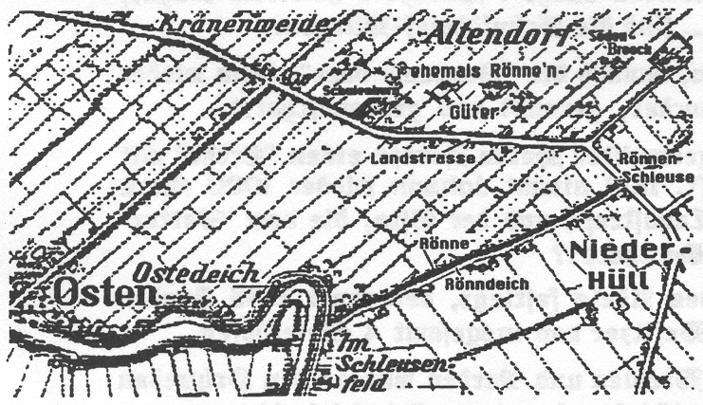
ALTENDORF III (also “centrist estate” designated) Paradum Wedekin’ widow married “de Styde”, from whom Dirich von deme Runne bought it; then possessed by Claus, Dirich and Erick, Vörd Reg.S.156

ALTENDORF IV (also “greater estate” designated)
Formerly possession of the Söden, circa 1475, ascribed to the Otto von deme Runne and to his heir Johann. Owner also Estate Judge Gerd, (16th century)

“Both “family estates” were the possession of the Estate Judge’s family. In 1578, the brothers Gerdt, Claus and Barhold, each occupied an estate in Altendorf. The estate of Barthold, at one time Claus Starken’s estate, laid south of the country road and went likewise as an old noble possession of the horse hair mill at the entrance to Hüller Street. 1641-1651, Dietrich had the archbishopric’s concession for the mill; after that Barthold. The estate went to Claus Schmoldt and 1757 to Jacob Schichting, married to Anna Drewes.

It is said, that Judge Johann’s manor in Altendorf, which he had bought in 1636, westward on a family farm joined, and, yet 1657 had Detleff von Rönne a farm with 30 ½ acres of arable land in Hüll, which went later to the family Hottendorf.

Between 1732-1790, the Schmoldts occupied two farms in Altendorf. Circa 1790, an ancestral family is on a family farm; on another resided the Schlichting brothers.

YEAR 1689 / Dike Law related to “Altendorf Sea Dikes”

“To know, be herewith each one, separately to each, so with it interest, that afterwards the occupying heirs of the Altendorf farming business of the Osten Parish, particularly the upper residents’ honorable estate lords and residents, with the residents in Kirchdorf, and which to the Dike Regulating of the making and repairing of the sea dikes in legal process advise, in this now, Kirchdorfer and Dike Regulation to help with such work would not understand each other; on the other hand, however, it is judged to be an obligation. Of such litigation, however, at the mediation of Lord Dike Greven Squire Gerdt von Rönne, in ensuing form, in gentlemanly goodness and motive, made up and settled”.
The entire agreement is printed in the “Chronicle of the Osten Parish”.
Under which, we find altogether 37 signatures (1689): Gerdt von Rönne m. pria/Burchardt von Rönn m.pria/Bartheldt von Rönn m.pria.
“m.pria” is “manu propia”—which is to say: signing with my own hand.
Year 1697 / Eastward of the Elbe River (from State Archives at Rostock)
Gustav Adolph von Rönne, gentleman in waiting, born 1676 at Doltzein (Tolzin?), was buried at Güstrow (Mecklenburg) with a funeral sermon.
His siblings were: 1. Magdalene Sybill; 2. Hedwig Sophie; 3. Elisabeth Agnes; 4. Catharina; 5. Jügen Hinrich (without more!)
Georg Heinrich von Rönne at Brook, Broock=zw. Lubz and Plau (Mecklenburg)?
Chief master hunter, born circa 1600, wed to Ilsabe von Halberstadt of the house Pelzin
And daughter of Curd Hans von Halberstadt and Elisabeth Hedwig von Oldenburg.
A son of Georg Heinrich von Rönne was:
Anton von Rönne at Brook, Brandenburg Captain, wed to Elisabeth von Schönebeck of the House of Schönebeck (by Magdeburg).
A son of Anton von Rönne was:
Hermann von Rönne at Brook, wed to Clara von Reken of the House Leuner, daughter of Christopf von Reken and Sophie von Issendorf of the House Öse.
A son of Hermann von Rönne was:
Jügen von Rönn of Brook, Notary for Legal Defenders, born in the year 1704, married to Anna von Sickensalt of the House of Sickensalt.

Mrs. Von Rönne, born von Sack, widow of Gerhard von Rönne (born 1697 and formerly Captain at Paarlauken in Memel jurisdiction), married in 1720 Major Hans von Schönebeck. Son Georg Christopf von Rönne studied in 1725 in Jena.
--This Gerhard (Gerd) von Rönne (born 1674 Altendorf) according to Mushard was in the Swedish War Service (Son of Dike Count Gerd v.R.)

16th/17th Centuries/Marriage or Convent/Rönne Daughter Readout
With these following named unmarried family members, one could not with certainty integrate chronologically.
Adelheit von Rönne of Riedtheim Wed Hans von Plate of Klint by Drochtersen
Adelheit von Rönne, Detlebs daughter Wed Hinrich von Plate of Grabow/Klint
Adelheit von Rönne, of Altendorf Wed Heinrich von Goldocke of Berenitz
Adelheit von Rönne Wed Gerhard Anton Plate, Schölich III, after 1708
Anna von Rönne, Claus’ Daughter Wed Otto Segemann at Seediek
Amgard von Rönne of Brook Wed Hinrich Becker
Becke von Rönne, Clawes’ Daughter Wed Johann Plate, Mayor of Stade
Charlotte Sophie von Rönne, Nun in Cloister Stolpe, Died 1753 in Hamburg
Christine Adelheid von Rönne Wed Johann Ernst Platte, Schölich III, lived 1703
Elisabeth von Rönne Wed Augustin von Brummer, lived 1700
Gödele von Rönne, Claus’ Daughter Wed Hinrich von Hadeln, by marriage Lord of the Manor at Freyburg
Gödele von Rönne, Gerd’s Daughter Wed circa 1680 Johan Drewes, Lord at Hamelworden
Helene von Rönne of Altendorf Wed Gerhard von Wiedershaufen
Heylwig von Rönne Wed 1683 Hinrich von Bohlen in Osten Parish
Lucia von Rönne, Nun in Cloister Himmelpforten, after 1648 in New Cloister
Magdalene Adele von Rönne endowed “to a charitable purpose” 1000 Mark
Margareta von Rönne, Claus’ Daughter Wed Erich v Hadeln, by marriage Lord of Allwörden
Margareta von Rönne Wed 1665 Hinrich Zimmerman in Osten Parish
Margareta von Rönne Wed 1689 Frerck von Bohlen in Osten Parish
Maria Ursula von Rönne was in year 1656 Nun in Cloister Zeven
Metta von Rönne at Altendorf Wed Georg von Klenck at Schlüsselburg
Metta von Rönne at Altendorf Wed Claus Bulhorn in Osten Parish
Rebecca von Rönne Wed 1553 Hermann Erdemann, Pastor in York

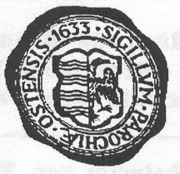
Year 1746 The new church receives Barthold’s bell from 1617

“The church signet is an elongated, subdivided shield: on the right half, a standing half eagle; thus, as on the left, four streams, one above the other, are seen. The inscription is: Seal-Parish-Osten 1633”.

In the Chronicle of Parish Osten, von Richard A. Rusch writes:
“Because the old church with time became in such a state of disrepair that it, each moment, an inspiration appeared to loom; as a result, one thought about a new building, and which, so much more, as the old was also so confined and small: that the entire very growing and popular congregation could not secure…The church cost 30,000 Reichsthaler and is most regal and worthy in the whole country…Ten feet deep in the ground, on the west corner, lays the cornerstone in which a tin table with a gracefully placed inscription is found”----
The inscription is in Latin penned and translated accordingly:

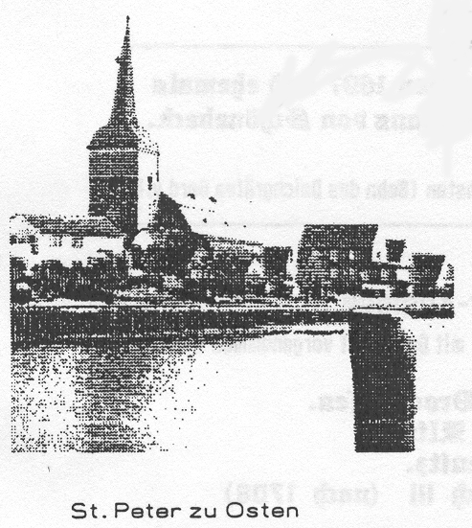
“With the aid of a godly faith and the Benevolent George II, of the most gracious, powerful and glorious kings of Great Britain, France and Ireland and Duke von Branschweig and Lüneburg; Georg Ernst, Baron of Schulenburg, Burchard von Brook and the royal Judge Adolph von Beck wisely guided the work and carried on with untiring devotion; and chose wise men from the farmers: namely, Nicolaus Schmodt, Johann von Rönne,Georg Drewes, Gerhard Sparnecht and Paridon Schmoldt, with the famous architect Johannes Leonhard Prey and the current two pastors Wilhelm von Dein and Daniel of Aspern. In the same year, in almost all the Dukedom Bremen and, as a part, our parish was, out of it, miserably devastated through a terrible cattle disease. In the year of recovery 1745, on June 9, one began our church, which was from former years in disrepair by neglect of support and repair, together with the dilapidated tower take down and from the foundation tear off. A new foundation then in the fall of the same year was laid, and then, the helpful, friendly weather, the work wonderfully encouraged, fully finished and, as the year waned, was covered with dirt. In the following year, 1746, began the workers on May 11 with renewed ambitious work, the wall work to erect and gave the church its former name: namely, ST. PETER.

And for a lasting memorial is this memorial with the enclosed tin tablet inserted into the wall. Etc.”
In September 1981 the church spire with clock and bell was removed and repaired. An inscription again said that the bell was from the former Osten Judge

BARTHOLD von RÖ NNE
donated in 1617 and then 1746 from the tower of the old St. Peter Church carried over.

Year 1709 Carl Ewald Rönne, Baron and Russian General

Beginning in year 1439, like his great grandfather, Johann von Rönne was bestowed by Archbishop Henning von Scarfenberg with a feudal tenure land grant in Livland. Already do to “tradition” this one was titled "Captain at Rönneburg”. Then bestowed with the land he should himself cultivate. The son owned this land grant Tauren, also the estate Serben. From the descendants a Michäl von Rönne, circa 1555, took over the Livland estate from his brothers Johann and Georg. His widow was allowed to renew the estate ownership deed for herself and her 7 children.

Circa 1630, Herman (Heinrich) von Rönne, through his marriage with Amalie von der Brucken, received ownership to Wensau. They had at Reval, on Dec. 15, 1663, given birth to a son Carl Ewald von Rönne, who, the Livland estate being lost in the war, enlisted himself to the military and served in various armies. As the Swedes invaded the Baltic countries, and in 1700 had conquered the Russian Army at the Darwa Fortress, the then Tsar Peter availed himself of new soldiers and the Carl Ewald. In 1704, the Ingermanland was again under Russian control in the year 1709, coming at the decisive battle at Potawa.
In the biography “Peter the Great” by Henri Croyat, it is said: In May 1709, the Swedes reached Potawa in the heart of the Ukraine. The old weakly fortified city was defended by a garrison of 6000 men. Karl XII encircled it; however, not immediately attacking. Intoxicated by many easy victories, he committed an error, his opponent to underrate.

At the break of dawn, June 8, 1709, the Swedes attacked, before the little plain, a swamp, entrenchments and gun emplacements. The center of the Russian Army was commanded by Scheremetjew; the right flank by von Rönne; the left flank by von Menschikow and the artillery by von Bruce. The Tsar shared personally at the from of the two battalions of the Dowgoroden Regiments. However, in reality, he was overall the same: with fire in eyes, foam on the lips, he rode ahead on his Arabian steed over the battlefield, shouting orders, encouragement and insulting words,…The “Karliner” was quickly crushed by the supreme numbers and by the enthusiasm of the enemy and moved back in a disorderly retreat. In vain screamed the lieutenant: “Halt! Stand! Shoot the King!” The heroes of yesterday were only yet terrified bloodily injured, who threw away their weapons and took heels in the direction of the Dniepper River.

It rained reward: Field Marshall Scheremetjew received a landed estate, Menschikow was appointed Second Marshall, Rönne to Commanding General, Golowin to Chancellor, the “Little Jude” Schafirow to vice Chancellor. The soldiers were awarded medals. Peter, himself, was not forgotten. The officers, whom he had honored, presented him the ring of a general chief of staff by the ground troops and accepted by a Rear Admiral at sea. His majesty fulfilled this request.”—

Otherwise, 2 years later, the Turkish Army had surrounded Peter at Asow. Scheremetjew was able to save the Tsar and Tsarine through a peace treaty, because the Cavalry General Rönne and Tschiriwow Braila threatened, whereby through the retreat route of the Osmanen was exposed to danger.
Carl Ewald von Rönne was married with Anna Lucia de Preen, heiress at Puhren, Wilzen, Wieseln and Padden. He died 1716 at Brody (Grodno) with the army and was their great tsarish majestic General of the Cavalry, a colonel of a regiment of horses, a Knight of the Russian St. Andreas Order, Knight of the Polish White Eagle Order, Knight of the Russian Order of the Generous, Knight of the Order of Reconnaissance, etc. and was elevated by the Tsar into the status of a baron. Added to that, he was Lord Successor to Ronneburg in Livland, Master at Bershof, Puhren and Wensau and was granted a new authorized baron coat of arms.
Year 1756 Sale of Altendorf Estate to Peter and Jacob Schlichting

As Lord brothers Earl Hinrich, Christian Wilhelm and Hinrich von Rönne, of the Weyland Barthold Schlichting widow and heirs, on account of whom, after the demise of the Lord Lieutenant Hinrich, owing her money as that of her bequeathed, who….

Year 1766 Letter of Christian Wilhelm v Rönne to Brother Schlichting

Very dear, honorable Lord,
The honorable writing with 4 & ½ Luidor, have I well received, a status due to Your Highness, as also to the Lord Brothers, my genuine thanks in advance. From Your Highness’ writing I understood, that the same, as also the Lord Bruder, one each, not more than two wanted to give me, likewise 4 Luidor annually I hope to have and that it should by Michael, so be remitted and at all times here to be paid. Then it as a result can be no other and I have it from your estate and goodwill. So must I, myself, conform to it and about it be content. It wants to me well somewhat a little to arrive that I a Luidor fewer receive. In this I wish from the heart that the highest, the same as also the Lord Bruder yet many long years may be preserved with continuous good health, for which I,Your Highness to the Lord Bruder recommend, and persist to his Royal Highness of my highest honored Lords.
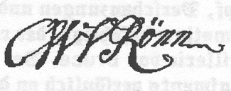
Foxstedt, 2 December 1766 Cordially, signed

1777 - 1839 From the life of surveyor Christian Wilhelm von Rönne

A family chronicle of ones various experiences of the “untitled line”, descendants of Christian Wilhelm von Rönne from Otterndorf, was written for posterity as follows:

“In younger years Christian Wilhelm von Rönne traveled to Helmstedt, in order at the university there his entrance exams to take. On the evening before, he became acquainted with an Englishman, with whom he discussed extensively. On another morning, the Englishman was very much strangely discovered dying. Christian Wilhelm von Rönne came, of course, into suspicion, him to have slain. The inhabitants were filled with anger and threatened him violently. With a weakened voice, the Englishman, however, could shortly before his death, say that C. W. von Rönne was not guilty and he himself had wondered very much.
After this terrifying experience Christian Wilhelm traveled the same way back home and never took the entrance exams. He lived, to begin with, as a distiller; then, later, as a surveyor, land measurer in Otterndorf.
This C. W. v Rönne married in May 1808, Sophia Louise, a daughter of Johann Balk from Wischhafen, who presented him 2 sons and 2 daughters.

In January 1816, they entrusted him with the “Office of Land Management” for the assessment of the land tax survey. The “Surveyor von Rönn” did this in the years 1817-1826 and reckoned on 111,961 ½ acres, Moor and Heide into account. (see Scherder’s Chronicle, Page 633, respectively Hadler’s Chronicle of 1979)
In the year 1826 the business “Ronne Land Management”took over management of the remaining resources of Lord Havemann in Brüninghemm.

Year 1793—The Rönne Stone by Witsum on the Island Föhr
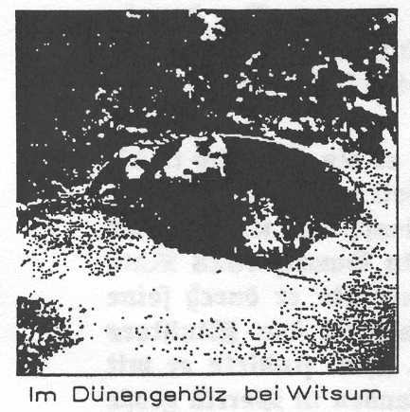
Under this stone was discovered a coffin, in which Johann Caspar Rönne was dishonorably buried. This man was count marshal and civil servant at Nieblum (Föhr). He had come from Hamburg or Altoona above Stapelhom with a sickly wife, who soon passed away. Once more misfortune seemed to trample on his life, as he married the widow of Gundel Oluf, who gave him 5 children in their 8 years of marriage. She, then, also died and one, a daughter Maria Fessen, from Gundel’s first marriage with Hans Fessen, must take care of his household.

Unfortunate was Johann Caspar. He approached 60 years and seized a passionate lust for his adult step-daughter, who, on the part of Maria remained unanswered. Destiny took its course. After a few years, she presented a daughter the life, who received the name of the mother.

According to the laws of the time, illegitimate births were punished. The Birkvogt Matthiessen conducted a trial (hearing) in order the child’s father to determine. Maria named a drunken mill laborer from Wyk as father, and should, after which allowed the child a little more peace, enter upon her punishment. After an official investigation, Maria must now come clean, that she had even further brought an allegedly dead child into the world; which she had in an earlier hour hidden. And now Maria confessed the relations with the step-father, and that she had, contrary to the laws married him. Johann Caspar likewise was interrogated and confirmed the account.
Two oral doctors examined the dead child and came to the certainty that this child lived at birth and under a pillow was choked. Now both were arrested and Rönne locked up, bound hand and foot. The auction of their possession on the island of Föhr by the chancellors of the church were made public.
However, 3 years, Maria and Caspar sat imprisoned. Before, in October 1793, a pleasing decision came; Föhr belonged to Denmark, which through the government at Copenhagen was confirmed.
Accordingly, because of incest, concealing the birth and the infanticide, both should lose their heads by the axe. Subsequently, to them both, before this, their right hands should be cut off and Johann three times with red hot tongs be tweaked. Their heads should be set on poles; their bodies burned on a place of execution.
As to the execution, it did not take place. Johann Caspar Rönne was, in the days after the pronouncement of judgment, found dead in the cell, his body hurriedly buried in the dunes of Witsum. Maria became insane and, in February 1807, at 43 years of age, set free. No one knows where her life ended. Their little daughter was at 7 years, dead from small pox.

Descendants re: origin of Johann Caspar Rönne, born between 1730 and 1735 is not shared. From his 1st wife Margareta Henselmann ,circa 1740-1776, was a daughter, Anna Katharina Rönne, who lived 1766-1794
His 2nd wife Gundel Olufs (1741-1786) brought 1777 out of her marriage with Hans Jessen 3 daughters: Maria Hansen, born 1764; Catharina Hansen, born 1767, and Helena Hansen, born 1769. Further residents received earlier the father’s last name as family name; thus “Hansen”.
From both times, eight years during the marriage were 5 children: Johann Adolf Rönne (1777-1777), Otto Rickmer Rönne (1778-…), Johann Adolf Heinrich Rönne (1780-1784,), Catharina Margareta Rönne (1781-….), Johann Adolph Rönne (1784-….)
Unmarried with Maria Hansen were: Maria (1789-1797). And without a name a child born in 1790.
The son Otto Richmer Rönne traveled later as Captain of the Sea, married in 1801, at Nieblum on Föhr, to Tadt Bohn (1779-1835) and had with her the children: Inge Arding, born 1806, Lorenz Volkert, born 1813, and Otto Rickmer, born 1814, died 1815.

Years 1798-1865 Friedrich Ludwig von Rönne (from A.D.B. XXIX. 133)
Friedrich Ludwig von Rönne, legal scholar and Prussian politician, was born on Nov. 28, 1798 at Sestermühle, an estate by Glückstadt. The father Johann Georg von Rönne, at that time Hannover’s junior barrister in Stade and later a member of the Holstein government in Glückstadt, “awoke in him at an early age a high and noble desire, a driving judicious force, genuine human kindness, as he, also, laid the groundwork for his many faceted education”.

Rönne attended the Gymnasium in Glückstadt. Yet not 16 years old, he enlisted in the German-English Legion, as a cadet junior grade, with which he took part in the Battle of Waterloo. In Kiel and Berlin, he studied law, entered the Prussian legal administration and became, in 1823, assistant judge with the Superior Court of Justice in Berlin; in 1825 with the Regional Court of Appeals in Hamm; in 1828 Counsel at the Superior Court of Justice; 1831 Counsel with the government of Potsdam. Here he evoked, by his familiarity with the state and international affairs, the attention of Minister Ancillon, who, in 1834, sent him as resident minister to Washington. Here, he studied with great enthusiasm the trade relations of North America. His reports found in Berlin, great recognition by the government and by the trading classes.

Rönne made many trips to the Union, in order to promote the interest of Germany. He received high regards and affection by the Americans. With certain statesmen was he closely well known. He was effective in the interest of the German immigrants and troubled himself, unfortunately needlessly, because of a trade agreement between the Hassidic Cities and the Union. However, he was able to extend the existing agreements wherefore to him for his part, was abundant gratitude in Hamburg and Bremen.

Friedrich von Rönne was called upon, on the basis of his esteemed reputation in America, repeatedly to international arbitration. Thus, trustworthy, he was a war between the Union and Mexico to prevent. Due to his successes, to him later, the arbitration office of the conflict with England with France over the gum trade at Senegal was negotiated. In 1834, he came back to Berlin at the order of King Friedrich Wilhelm IV, because the Trade and Business situation, a Trade Ministry, demanded it and von Rönne, as director, held his own. Friedrich von Rönne, himself, was subject immediately to the King alone as an intermediary of the subordinate trade departments. His memorandum was announced to the ministry; this ministry expressed itself completely with the exception of the Minister of the Exterior von Buelow, against the plan because the men from trading classes did not appropriately consider its advice. The king decided the establishment of only one subordinate department, which for all that should be called the Office of Trade and appointed Friedrich von Rönne president, with the rank of Counselor First Class and a member of the State Counselors. Nevertheless, the disagreements with the Ministry of Finance remained. First in 1848 named to the extraordinary envoy to Washington; where he, in January 1849 together as envoy of the Reich administration exchanged ceremonies discussions with the President of the Union. In 1857, he went on his own accord into retirement and accepted a liberal political mandate to the Prussian Chamber of Deputies from Solingen—Lennep. He entered into international law, the legalization of the principles of immunity for personal and private ownership at sea in times of war, for the repeal of the necessity to carry a passport, and others. In 1862, he crossed over to the newly well informed progressive party and in 1863 expressed himself for the independence of Elbe Dukedom and against a Customs Parliament.

Friedrich von Rönne was married to a daughter of the senior officer of health and died on April 7, 1865 in Berlin suffering “as a result of bad inward parts of conference halls)
His son Julius published in 1867 in Berlin: “Friedrich von Rönne, The Main Drive of his Life and this treatise about the Constitution of the United States”.

Years 1804-1891 Ludwig Peter Moritz von Rönne (from A.D.B. LIII. 458)
Ludwig Peter Moritz von Rönne legal expert and brother of the aforementioned general Friedrich von Rönne, was born October 18, 1864 at Glückstadt. The family von Rönne was a member of the Hannover and truly to the old Bremen Knighthood Royalty. The father Johann Georg von Rönne descended from the remaining main line of the family in the country and was at this time a member of the current chief court for the Holstein Dukedom, who together with the administration of businesses encumbered. The mother was Caroline Sophie Chistine, nee Cordemann.

The genius of the family, however, from the father’s side, as that of the mother’s, always was and remained real German, as already the participation of the older siblings in the war against Napoleon, be it in the Russian service or be it in the English-German Legion, as indicated, into which the brothers with the consent of the father entered. As indicated, it happened then; well thought out, well planned and systematical, that the father led his youngest son to the Prussian State Service, from where, they then made such an application.

First of all, private training by the preacher Börne from Kahleberg (Angeln); the attendance at the Glückstadt “Teacher’s School”; from 1820 University Studies in Bonn and from 1822 in Berlin. After which, in 1827, he was to the successful secondary school teacher’s exam, on the recommendation of the late Minister of Justice from the mills to the Breslaür Chief Court sent. He completed in 1828 the great state written examination and was appointed immediately to the chancellor with absolute right to vote with the Superior Court of Justice in Berlin and, together with the representation of the well known Dr. Hitzig, as director of the Superior Court Interrogators, put in charge. So then, further to a County and City Court in Munsterberg (Schlesien), from 1832 Director of Country and Land Court in Hirschberg; from 1836 Counsellor at the Court of Appeal at Breslau; 1843 Counselor to the Superior Court; 1859 Vice-President at the Appellate Court in Glogau.

In the year 1868, he took leave from the Justice Service and moved into Berlin in order to devote himself exclusively to “literary and parliamentary professional activity” to advance. To such literary activity Ludwig von Rönne, above all, led the way, in that he in 1815 published “System of Prussian Law”. Together with his brother Friedrich, published a new version in 1833. Then came into being, during the Breslau years of extensive work: “Supplementing and expounding of Prussian law books through legislation and science”, published by R. Graff, E. F. Koch, Friedrich von Rönne, H. Simon and A Wentzel; 13 divisions, 7 supplemental volumes, Breslau 1837-1849, in 3 printings.

Together with the Counsel of the City Court, H. Simon, he produced a compilation of sources for aggregate Prussian Constitutional and Administration Law, according to current legal status, a Travel Experience in 1846 alone, since Simon had departed. He occupied himself as a prime leader in public law for the German Empire, as “The Constitutional Law of the German Empire”, and gave, already in 1871 exercise books 1 & 2 of Hirth’s Annals, a 1st presentation about “The Standing Law of the German Empire”.

Besides his activity as a jurisprudence author, he was active as agent of the electoral districts Hirschberg-Schonau 1849, in the Chamber of Deputies, affiliated himself with the “Left Central” and was from 1858-1878 a regular member of the Chamber of Deputies, of the north German and German Reichstag for the Old-Liberal, and later, National Liberal Party.

For his work with the Prussian National Law, the Constitutional and Administration Law, etc, the star for the Crown Order, Second Class, was bestowed upon him. His marriage with Ottile, nee Kuhlmeyer, lasted a full 63 years. Dec 22, 1891, after a long illness, he died in Berlin, where the “Rönne Street” in the Charlotten suburb, was named after him.

These lines about the brother von Rönne from the autobiography. Entry records (A.D. B. =German Public Library) given again abridged.

Year 1843 A dedication to Anna Clara Elsner von Gronow, nee von Rönne

Clara von Rönne, born July 4, 1832 at Hirschberg (Schlesien), a daughter of Ludwig von Rönne, was in her eleventh year, when Wilhelm Grimm, one of the famous fairy-tale brothers, at the time a neighbor of the von Rönne family on Lennestrasse (Berlin-Tiergarten), wrote to her the friendly words in a Brothers Grimm fairy tale book.

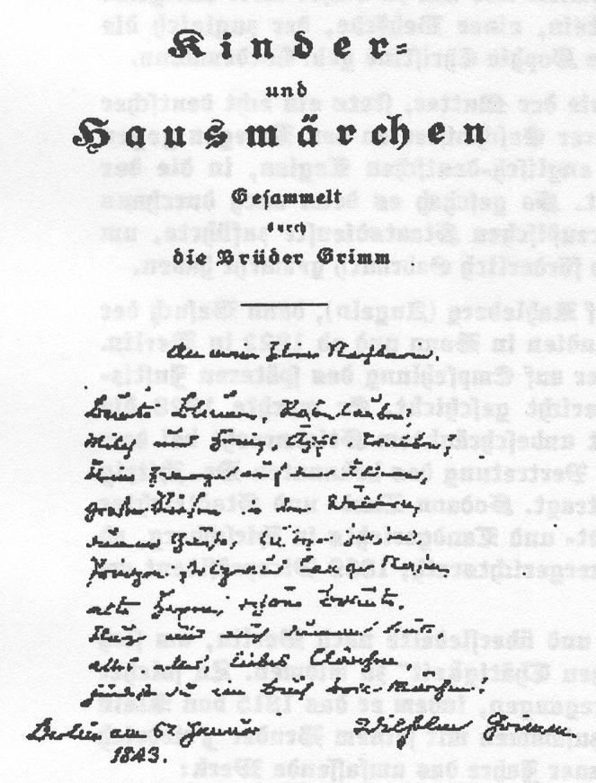

To my little neighbor girl!

Colorful Blossoms, Rose Leaves,
Milk and Honey, Apples, Grapes,
little gnomes from the fields,
dumb geese, merry rabbits,
Princes, proud of long noses,
old witches, beautiful brides,
clever, and also dumb people,
everything, everything, dear Little Clar,
you find in the book full of fairy tales!!

Berlin, on January 6, 1843 Wilhelm Grimm

The parents, Ludwig and Ottilie von Rönne, died in 1891 and are buried at the Matthai Cemetery in Berlin.
Anna Clar married to the Knights Estate Owner Elsner von Gronow at Kalinowitz in the county of Gross Strelitz. She died in 1893 in the old age of 61 years, likewise in Berlin/Litchterfeld. The brother Otto von Rönne left record of this. A son Kurt Elsne von Gronow was the War Court Counsellor at Danzig, died in 1863 at Stellin, and placed to the German Public Library the family tree and the autobiographic records of his youth and of his grandfather Ludwig von Rönne for availability. An uncle Kurt, husband of Ditmar Braun, teacher in Hanover, placed for this chronicle a copy of dedication for availability.

The fairy tale book found itself in the ownership of the family Martin Ludwig Elsner von Gronow in Hagen (Westfahlia).

Year 1830 Cordt von Rönne at the Rönneschleuse (Grosswörden Parish)

On October 17, 1830 Cordt von Rönne received authorization for building a lock on the larger Rönne. The dike director Claus Sürer, the dike sworn enemy F. H. Hohtwalker, and the interested F. D. Elfers, E. D. Borchers, D. Shütt and H. Walker, however obliged to give Cordt von Rönne a “free passage through the barn” for the dike workers and interested ones.

Year 1836 Claus Diedrich von Rönne at Rönneschleuse (Grosswörden parish)

Six years later on March 9, 1836, at the pinnacle, a large gathering of persons met with the dike director Peter von Holt, because Claus Diedrich von Rönne wanted to build a little barn on the larger Rönne next to his house to the north. He received authorization, naturally with a few conditions; among others, that the barn “must stay 3 feet away from the Rönnen bank at the small place; a free “passage” if Rönn will hand over, that obstruction or bulwark to the Rönne to keep. In addition, also a few things, before it he was able to begin with the little barn building!
On the basis, Claus Diedrich von Rönne and his son Johann in the year, completed a “Delivery and Purchase Contract, owing on the account of the Rönnen lock which imposed a tax from the Rönn living place, must on April 30, 1870 itemize a property assessment; the above mentioned Claus Diedrich and three children had accepted.
The children were: 1. Anna Margaretha, wed Hochmuth at Rönneschleuse
2. Anna Rebecca, wed Siems at Cranenburg
On the same day between the following persons are: 1.Claus Diedrich von Rönn at Rönnenschleuse to the one: 2. Home Innkeeper Johann Öllrich at Grosswörden; and 3. Master brick layer Christoph Böker from Niehhagen,on office days in Lippe-Detmold, on the other parts, an “agreement drawn up and, well considered, was finalized”.
Claus Diedrich von Rönn had since years set up and run a brick factory on his spreading ground pieces in Schleusenfelt. Claus Diedrich von Rönne sold and signed over the brick works with all the equipment to the two designated (Öllrich and Böker), “in such a manner, that the buyers entered solidarity”. As now of the ground and earth on which they in discourse placed the buildings; meanwhile member of the vendors became carried over, thus it was here explicitly noted that the buyers because of expenses that might be incurred, lease the property at Rönn lock to Hinrich Hochmuth, conducting itself with suitable risk and costs.”
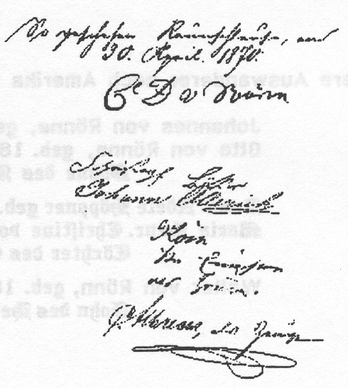
The purchase price for all the specified items “is stipulated 800 Thaler Courant and should, the
same be paid as follows: Until Michälis 1874 the buyers 200 Thaler to pay; the same in addition until Michälis 1874 200 Thaler Courant; the same until Michälis 1877 again 200 Thaler Courant; the same until Michälis 1879, balance with 200 Thaler Courant. The purchase price will, from Michälis 1869 be reckoned to the time of accession and by tradition of the sold items already happened and from which point in time, on the buyers into the liability entered; also on the same
hurried encumbrance and sales have taken over, from the buyers with 4% per annum paid interest.” Also the question of payment in case the brick works, during the terms of the contract should burn down, should yet be thoroughly explained in detail.
Year 1871 Emigrant Friedrich Christopher Marcus von Rönne

Friedrich Christopher Marcus von Rönne was born in 1842 Grabenstrasse Nr. 11 in Neustadt on the Baltic Sea. His parents were Carl Christian von Rönne, born in Kiel 1802, and Henrietta, nee Stoterog from Grömitz on the Baltic Sea.
In the year 1871, “Frederick” emigrated into the USA (United States of North America) and married there in 1873 in Glendale (Cass County/Nebraska) Martha Jane, nee Lewis. In Weeping Water (Nebraska) he bought a farm, which he expanded in the course of his life. In 1920, Christopher Marcus Ronne, as he now called himself, highly esteemed in Weeping Water and left behind 5 sons, in addition 2 daughters, who themselves likewise write “Ronne” (spoken Rhone ‘long o’ and ‘long e’). Frederick’s son Benjamin Franklin took over the farm and lived until 1972 (see listed below).

The 5 sons of Friederich Christopher Marcus Ronne were:
1. Charles Emery Ronne 1876-1954 no children
2. George Ernest Ronne 1877-1955 3 sons and 4 daughters
3. Benjamin Franklin Ronne 1883-1972 4 sons and 3 daughters
4. Roy F. Ronne 1885-1967 2 sons and 1 daughter
5. Jesse Martin Ronne 1889-1935 3 sons and 3 daughters

Included in these children and grandchildren are Officers (2 colonels); several government employees, teachers, construction builders, railroad engineer and always again the farmer, as to us Mrs. Marion Heesch (of Hamburg), a great granddaughter of Carl Christian (Kiel) has shared.
For the first time in November 1983 know the grandchildren, that their grandfather came out of Germany.
The first Americans (Lowell and Cora) had in the summer 1984 visited Hamburg and Osten.
The following listed forbears of Friedrich Christopher Marcus von Rönne were all born in the Schleusenfeld between Rönndeich and Ostendeich.
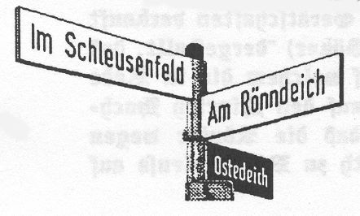
1. Martin von Rönne 1767-1850, died in Kiel
2. Hinrich von Rönne 1739-
3. Cordt von Rönne 1713-1762
4. Cordt von Rönne 1665-1738
5. Hinrich von Rönne 1630-1679
6. Hinrich von Rönne before 1610-1677

Additional emigrants to America were:
Johannes von Rönne, born 1872, and
Otto von Rönne, born 1887
Sons of Albert von Rönn (1850), travelling musician in Elmshorn.
Anna Adele Höppner, born von Rönne in 1858, with Fritz Höppner,
Maria Henrietta Christine von Rönn, born 1865
Daughter of Ernst Friedrich von Rönn (1821) in Schleusenfeld.
Walter von Rönn, born 1898, with Wanda nee Borchers from Altendorf
Son of Hermann Jakob von Rönn (1869), inn keeper at Basbeck.
Year 1855 Christian Wilhelm von Rönn, Wind miller at Cadenberge

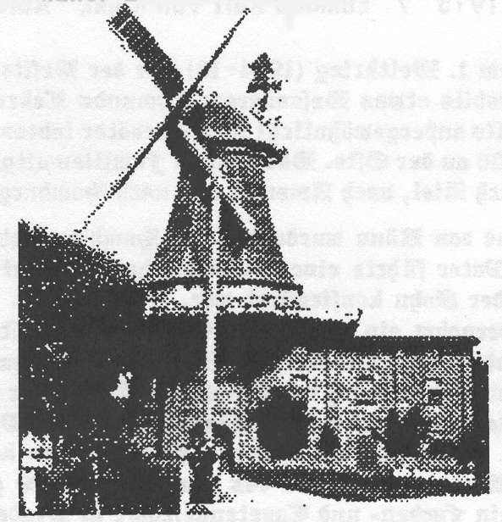
This former and widely conspicuous mill was built in 1855 by Christian Wilhelm von Rönn. Before that, here stood a ram type windmill, which belonged to the noble estate Cadenberge of the Lords from Bremen. Already in 1643 stood an old mill in the
south part of their park. In the year 1818, the 30 year old miller Martin Hinrich von Rönn took over the ram mill from father-in-law Johann Heinrich Jungclaus, but at first, his son Christian Wilhelm von Rönn (from 1848 a miller) bought this ram mill in 1854. It was in 1855 permitted to be torn down and replaced by a similar 4 storied channel-hollander. In the year 1911, Christian Wilhelm von Rönn died. And his son Barthold Georg, after that, was mill owner and agriculturist until 1962. He lived to see in 1955 a 100 yr. old Holland windmill and departed this life at the ripe old age of 93. Son Wilhelm von Rönne was miller—guild master at Cadenberge and moved, in 1963, with his old mother into a “new miller house”. The last sail-less mill in the meantime was electrified, adapted in 1968 by successor Gerd and died in 19….? Gerd von Rönn now runs the mill as a “Land Business”.

Year 1888 Albertus von Rönn, Chief master miller at Osterholz—Scharmbeck.
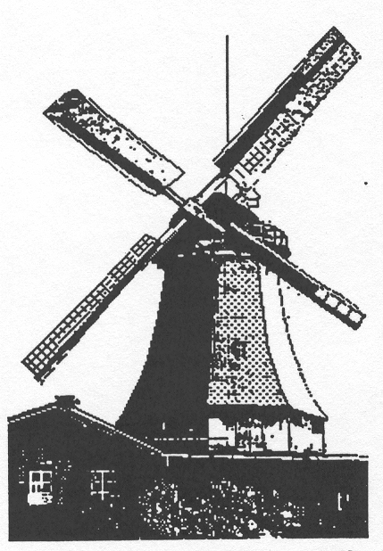
This Scharmbecker Dutch type windmill was built in 1882 and, from 1888-1992, was in the ownership of the family von Rönn. Wilhelm von Rönn, born in 1863 in Cadenberge, bought it. After his death in 1895 his brother, the merchant Albertus, took over the mill and, in 1910, became master miller. He lived from 1867-1958 and died in his 91st year. Civic associations, gun clubs, mill guilds, Agricultural—Industrial and Chambers of Commerce, countless other associations, the city director and many well known agents of the public congratulated the well preserved celebrant. Osterholz—Scharmbeck has not two men, who, in public life, invested with so many functions and to himself so much scrutiny could secure, as the old one from the mill on Linderstrasse, which today, under the name “Dutch Windmill von Rönn” includes several functioning mills on “Mühlenstrasse” bei Osterholz—Scharmbeck and by darkness are lit up. Already, the father Christian Wilhelm von Rönn, born in the year 1831, was a wind miller in Cadenberge, just as his grandfather Martin Hinrich von Rönn (1788-1841).

The last master miller at Osterholz—Scharmbeck, was, however, Albertus’ son Richard Albertus von Rönn, who, in 1903, was born in Osterholz and died in the year 1985. The heirs sold it under the status of a protected historical monument of a 2 storied-4 speed mill to the city.

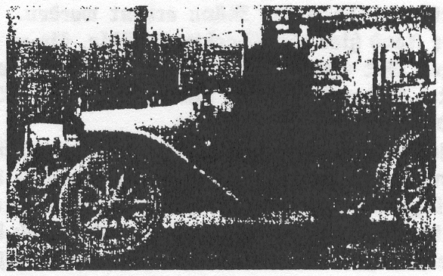
Year 1915 Edmund Karl von Rönn, Auto owner in Stade

Before World War I (1914-1918), an owner of an automobile was someone special. Edmund’s life was likewise unusual. The forefathers lived yet from 1800 on the Oste. Then family members moved away to Kiel, to America and Hamburg! Edmund von Rönn was born in Hamburg in His father ran an inn and drowned before Edmund was confirmed. So an uncle took over his rearing and placed Edmund into a painting apprenticeship. Indeed, our century brought forth the automobile. The Kaiser, himself, was very avid about the automobile. Edmund von Rönn took over a Ford agency, etc., and served so well that he to himself his own automobile and a house in Stade could provide. He was married twice, and had six children, of the youngest, who in 1929, was born Edmund von Rönn, who, had still in 1992 a cloth and tapestry business and had joined the traditional Shooting Association (gun club).
His grandson Nicolas Carl von Rönn was born in 1992.

Year 1917 Imperial Godfather for Friedrich Wilhelm von Rönn

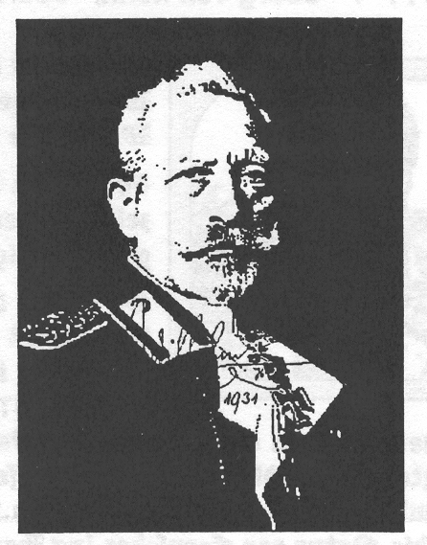
Also yet during World Ware I (1914-18) the last Kaiser, Wilhelm II, undertook the initial obligation and offered sponsorship for a family of 7 children to assume. Friedrich Wilhelm von Rönn received, in 1931, the Confirmation of his request for a photograph of the Kaiser, signed with his own hand from exile in Doorn, by Utrecht in Holland, where the retired Kaiser spent his waning years.

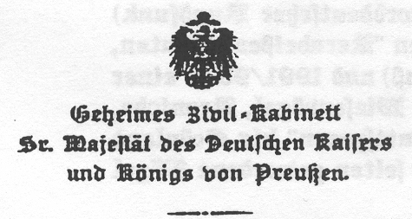

Secret Civil Cabinet
Senior Majesty of the German Kaiser
and King of Germany

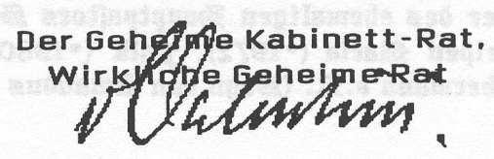
His majesty, the Kaiser and king have, by whom, on May 18, of this year, born 8 living sons of the mariner Heinrich von Rönn, at his own end, a personal sponsorship to accept and the enclosed gift of 60 Mark, out of their supreme cash box deigns to accord.
Signed The Secret Service
Cabinet Council
Authorized Civil Counsel

These 60 Mark were handed over to the mother by the chief mayor and later honorary citizen of the city Harburg on the Elbe River, by Heinrich David Denicke, on August 23, 1917.

Friedrich Wilhelm von Rönn descended from Krauts, an Elbe river island, and from resident family, and was born on May 18, 1917 during the 1st World War in Harburg on the Elbe, and traveled a few years as a ship boy. With 18 years, entered labor service, after that entered the war’s marines, became boatswain (as a sergeant) and was able, at first, at the war’s end and as prisoner of war to turn back to civil life. The destruction of the navy ships by the Norwegian coast, Friedrich (Fritz) had fortunately survived.
His father, Heinrich von Rönn owned, at first, a light naval boat with which he brought out of Kehdinger brickworks and brick stone to Hamburg. Necessitated by neglect of the brick factory, he must give up his ship and house on Krauts and moved, circa 1910 to Harburg and worked for a barge firm as “docking guide”. A son became a tug boat driver, a grandson likewise, received a “tug boat license”, traveled also on the senate’s motor launch.

A brother of his father, Martin von Rönn, as well, had his own light naval boat, which he then gave to his son Johannes and provided, with a motor launch, a personal ferry service between Krautsand and Glückstadt. This family is today on Krautsand, a grandson Hans-Hinrick is captain and engineer. He led the maintenance tradition forward.

Another brother of his father, Peter von Rönn, rode on “Elbe dredges”, had his wife and a little house in Cranz, where he died without successors.
Year 1991 Georg von Rönn, Journalist and Nature Cameraman for television.

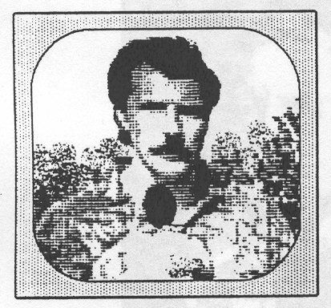
With German television, the family von Rönn, since the end of WWII, has brought visual information from the whole world direct into the living room.

The family von Rönn is interested in current events.
Georg von Rönn, is not only a good cameraman, who for a good ten years has produced interesting nature films. At the same time, he busied himself with nature conservation and preservation of our animal world.

Today’s NDR-Edition (North German Broadcasting System), already in 1984, so filmed by young conservationists, who reported in 1991-1993 about the Hunte (Weser Tributary), in a series “Ventures of Noah’s Ark”, covering white birds, cranes, life of animals on the Steppes, in the Watteman, etc. He filmed from “Knuttspuren” to Greenland and displayed to us wild cats, red ants and bearded vultures. Then again seldom to be seen birds as Blaukehlchen and bag tit mouse, and many more. He considered nature in the house and gave opinions or advice and correspondent courses at the same time.

PERSONALLY:
Georg von Rönn was born September 8, 1946 in Hamburg. He married with Suzanne, nee Sierig, a daughter of the former senior pastor Sierig of St. Catharine, Hamburg. Their 3 children are called: Maria (1972), Falk (1980) and Wolf (1984)
Georg’s parents are Hermann Rönn (son of Amandus von Rönn) and Irmgard, nee Blunck.

Year 1991 Sören von Rönne, Tax consultant and steeplechaser for Germany

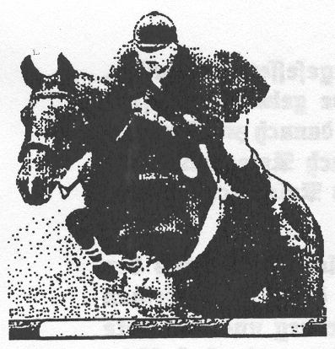
June 1991: International Steeple Chase Derby in Hamburg (K. Flottbeck)

The great surprise, in the German view, was the blond assessor Sören von Rönne from Neündeich by Ürtersen with his 10 year old mare “Taggi”. An error in the free ride in the second qualification run brought “newcomer von Rönne) third place.

A week, thereupon, the Sören von Rönne, won with the same horse with his first entrance in Aachen, the great prize of North Rhine, Westphalia”. A large newspaper (the Bild) wrote: “Super! Von Rönne jumped with Taggi into the world’s elite!!!”.

Also in 1992, the young tax consultant rode successfully. In May, he won the championship of Mannheim on “Taggi”; in June in Wiesbaden failed to win by only a millimeter (fastest / first throw off / third place with the mare “Wilma”). At the beginning of July, Germany, for the first time since 1986, won the “Prize of Nations” at Aachen at the International Riding Tournament, with riders Sören von Rönne, Dirk Hasemeistser, Otto Becker and Ludger Beerbaum, our German “Olympic Team 1992” in Spain.

PERSONALLY:
Sören von Rönne was born in Ütersen-Neündeich on July 13, 1962. His parents are the tax consultants Siegfried and Helga, nee Klinck, residents of Ütersen-Neündeich. Already, the forefathers lived, since the end of the 17th century north of the Elbe River (Elmshorn/Ütersen)

Wedding Times (copied notes from church registers)
Date of Marriage Lived from to
_________________________________________________________________________________________________________
5 Nov 1665 Margarethe von Rönne Dietrich’s daughter, horse hair miller at Osten,
wed Hinrich Timmermann
_________________________________________________________________________________________________________
28 Jul 1668 Johann von Rönne, Borchard’s son, of Osten
wed Elisabeth Lüdemann
_________________________________________________________________________________________________________
26 Apr 1670 Claus von Rönne, Borchert’s son 1640-….?
wed Beke Blohm
_________________________________________________________________________________________________________
25 Jul 1671 Metta Anna von Rönne, Detleff’s daughter in Hüll, 1650-….?
Wed Claus Bulhorn
_________________________________________________________________________________________________________
20 Oct 1678 Agatha von Rönne, 1660-1680 1660-1680
wed Peter von der Lith
_________________________________________________________________________________________________________
20 Jan 1683 Heylwig von Rönne
wed Hinrich von Bohlen
_________________________________________________________________________________________________________
24 Nov 1683 Burchardt von Rönne, Lieutenant Lord of the Manor at 1648-1710
Altdendorf wed Anna Juliana von der Kuhle at 1652-1698
Wellingbüttel
_________________________________________________________________________________________________________
5 Aug 1684 Claus von Rönne, Hinrich’s son
wed Catharine, nee Ollrichs, Hinrich Offermann’s widow 1641-1693
_________________________________________________________________________________________________________
7 Jul 1685 Hinrich von Rönne, in Schleusenfeld 1655-1724
wed Schwemke Marx, Hinrich Marx’s daughster 1664-1727
_________________________________________________________________________________________________________
1693 Dietrich von Rönne, Barthold’s son at Osten 1665-1708
wed Catharina Stöver, daughter of Claus Stöver 1671-1708
_________________________________________________________________________________________________________
4 Sep 1694 Albert von Rönne, Grossenwörden wed: 1661-1741
1. Anna von der Lith, Claus’ daughter on 4 Sep 1694 1670-1710
2. Margaretha von Ahn, Claus’ daughster on 29 Mar 1712
_________________________________________________________________________________________________________
20 Nov 1704 Hinrich von Rönne, son of mariner Claus of Oberndorf 1681-….?
Wed Margaretha von der Heide, daughter of Zimmermann, Deich i. W.
_________________________________________________________________________________________________________
5 Nov 1706 Johann von Rönne, deceased merchant Barthold’s son 1674-1716
wed Cathrin Stöver, Merchant Johann Stövers daughtser
_________________________________________________________________________________________________________
8 Nov 1712 Hinrich von Rönne, Cottager at Niederhüll 1687-1753
wed Metta Siepen, Harm Siepen’s daughter 1687-1758
_________________________________________________________________________________________________________
15 Aug 1715 Arendt von Rönne, Weyland Hinrich son in Niederhüll 1691-…..?
wed 1. Gesche Mau’en -1716
28 Sep 1717 wed 2. Sophie Schlichting, of Grossenwörden
_________________________________________________________________________________________________________
23 Jul 1722 Barthold von Rönne, merchant in Kirchdorf, Barhold’s 1695-1729
son wed /Dorothea Schmoldt, Harm’s daughter 1697-1776
_________________________________________________________________________________________________________
25 Oct 1725 Claus v R, Oberhüll, Hinrich’s son,of Grossenwörden 1695-1766
wed Catharina Stelling, Dierck’s daughster, of Oberhüll 1700-1762
_________________________________________________________________________________________________________
12 Jul 1725 Johann, v R, at Deich i.O. Hinrich’s son Grossenwörden 1697-1769
wed 1. Mette Behrmann, Claus’ daughter from Isenssee
29 Dec 1734 wed 2. Mararethe Schmidt, Claus’ Dtr. From Oberndorf
_______________________________________________________________________________________________________
12 Nov 1726 Hinrich von Rönne Albert’s son from Grossenwörden 1704-1752
1. Wed 1726 Anna Maria Steffens, Hinrich’s dtr., Deich i. W. 1704-1743
2. Wed 1743 Anna Sudhoff, nee Albrecht,
_______________________________________________________________________________________________________
23 Dec 1727 Hinrich vR, resident on Rönn Dike, deceased Johann’s son
wed Anna Elisabeth, of the deceased Christian von Düring Wittibe
_______________________________________________________________________________________________________
17 May 1727 Jügen vR, builder in Hüll, Barthold’s son in Oster 1696-1732
wed Ilse Albert, Dierck Albert’s daughter at Osten 1700-……
_______________________________________________________________________________________________________
18 May 1728 Claus vR, brick worker of Grossenwörden, born of equal class 1706-……
wed Mette Otten, Michäl of a cottager’s daughter 1700-1730
wed Margret Diese, Johann Peter Giesens daughter in 1731 1708-1778
_______________________________________________________________________________________________________
28 Dec 1729 Johann vR, trader in Kirchdorf, Johann’s son 1709-1770
wed Mette Gätken, daughter of innkeeper Michäl Gätken 1710-1764
_______________________________________________________________________________________________________
25 Oct 1731 Detlef vR, shömaker in Isensee 1706-1732
wed Becke Ahlf, deceased Claus Ahlf’s daughter
_______________________________________________________________________________________________________
28 Oct 1734 Peter vR, Cordt’s son, of Grossenwörden, born of equal class 1702-1764
wed Göhle Steffen, daughter of Claus Steffens, on Deich i.W. 1706-1752
_______________________________________________________________________________________________________
29 Dec 1734 Johann vR, son of Hinrich von Rönne 1697-1769
wed Margaretha, daughter of Claus Schmidt of Oberndorf, 1700-…?..
_______________________________________________________________________________________________________
11 Jan 1740 Harm vR, Hinrich’s son from Hüll 1715-1787
1. wed Gesche Ollrichs, nee Hinsch, Widow of Johann Ollrich 1715-1758
19 Jul 1761 2. Wed Margaretha Grantz, deceased Hinrich Grants daughter 1727-1782
_______________________________________________________________________________________________________
18 Jun 1750 Barthold v Rönne, Barthold’s son 1723-1757
wed Rebecca Haucken 1724-1792
_______________________________________________________________________________________________________
13 Oct 1750 Claus vR, son of Hinrich von Rönne and Mette Siepen 1726-1752
wed Anna Jarck, daughter of Hinrich Jarck of Grossenwörden
_______________________________________________________________________________________________________
8 Nov 1751 Catharina von Rönne
wed Johann Hintmann,deceased Johann’s son of Grossenwörden
_______________________________________________________________________________________________________
4 Apr 1752 Johann von Rönne, Hinrich’s son in Niederhüll 1730-1779
wed Alheit thor Borg, Grossenwörden Horst 1727-1789
_______________________________________________________________________________________________________
6 Jul 1753 Hinrich vR, tailor in Hüll, Hinrich’s son 1731-1760
1. wed Anna Mau, Daughter of deceased Johann Mau’en 1732-1785
2. wed Becke Daldorf, of Oberndorf on 2 Nov 1760
_______________________________________________________________________________________________________
27 Oct 1754 Metta vR, Albert’s daughter, born 4 Jun 1730 in Grossenwörden 1730-……
wed Johann Mau, Isensee, deceased Claus Mau’en’s son
_______________________________________________________________________________________________________
12 Apr 1757 Hinrich vR, son of shömaker Claus von Rönne in Hüll 1731-…..
wed Anna Maria von Rönne, nee Stelling, Claus von Rönne’s widow 1731-1760
_______________________________________________________________________________________________________
25 May 1759 Claus vR, tailor under the dike in Osten, Hinrich’s son 1734-1785
wed Adelheit von Beer, Schneider Friedrich’s Co. also located there 1737-1801
_______________________________________________________________________________________________________
10 Oct 1760 Jügen vR, Hinrich’s and Osten Parish’s son 1734-…..
wed Margaretha Marie Heinsohn, widow of deceased Pastor C. Meyers
_______________________________________________________________________________________________________
2 Nov 1760 Hinrich von Rönne, widower and tailor in Niederhüll 1731-1773
wed Becke Dardorf from Oberndorf 1732-1785
_______________________________________________________________________________________________________
_______________________________________________________________________________________________________
20 Nov 1761 Hermann von Rönne, Hinrich’s son at Isensee 1715-1787
wed Margaretha Grantz, daughter of Hinrich Grantz of Isensee 1727-1782
_______________________________________________________________________________________________________
16 Jan 1763 Albert vR, son of Hinrich the tailor on the dike in Osten 1729-1793
wed Mette Adelheit Brümmer, Claus’ widow who lives in Hüll 1735-1820
_______________________________________________________________________________________________________
28 Aug 1763 Johann vR, trader, heir by marriage to Dorf, Johann’s son 1729-1780
wed Dorothea Schmodt, nee Paridom’ daughter at Baljie 1747-1827
_______________________________________________________________________________________________________
4 Nov 1764 Johann vR, Hinrich’s son 1742-…..
wed Anna Margaretha Heinsohn
_______________________________________________________________________________________________________
16 Nov 1764 Hinrich vR, Cordt’s son from Grossenwörden 1739-…..
wed Mette Mahler
_______________________________________________________________________________________________________
25 Dec 1769 Hinrich von Rönne, Hermann’s son, Isensee 1745-…..
wed Anna Beckmann, Jakob Beckmann’s Co. at Hamelwörden
_______________________________________________________________________________________________________
21 Oct 1774 Dierck vR, cottager in Wörden, erstwhile Cord’s honorable son 1745-1819
wed Gesche von Bargen, erstwhile honorable daughter of Bargen 1747-1825
_______________________________________________________________________________________________________
30 Aug 1776 Albert vR, houseman in Wörden, Claus’ honorable son in Wörden 1751-1824
wed Abel Söhl, daughter of cottager Ernst Friedrich Söhl in Wörden 1755-1812
_______________________________________________________________________________________________________
20 Oct 1778 Johann vR, son of cottager Johann in Baljie 1754-1816
wed Anna Rapen 1755-1838
_______________________________________________________________________________________________________
4 Apr 1781 Claus vR, in Hüll, Cottoger Johann’s son in Baljie 1754-1816
wed Elisabeth Jarck, daughter of Hinrich Jarck in Hüll
_______________________________________________________________________________________________________
4 Jul 1782 Johann Christian vR, in Hüll, Cottager Johann’s son 1754-1816
wed Catharina Mette Breyer (Breür), Claus’ daughter, Isensee 1752-1832
_______________________________________________________________________________________________________
31 Aug 1782 Claus vR, Hinrich’s son, Wörden
wed Margaretha Krönke, Hackmühlen
_______________________________________________________________________________________________________
12 Apr 1784 Hinrich vR, tailor in Grossenwörden, erstwhile Hinrich’s son, Hüll 1755-…..
wed Anna Catharina Jungclaus, Leinwebers Jacob Jungclaus Co. 1760-…..
_______________________________________________________________________________________________________
15 Apr 1792 Johann von Rönne, Peter’s son Drochtersen 1767-…..
wed Catharina Meyer
_______________________________________________________________________________________________________
20 Nov 1793 Peter von Rönne, Peter’s son, Drochtersen 1771-1827
wed Adelheid Meyer 1770-1842
_______________________________________________________________________________________________________
20 Sep 1796 Rebecca vR, daughter of Johann vR & Catharina thor Borg
wed Christian from Osten, houseman at Hörne, Claus’ son
_______________________________________________________________________________________________________
2 Jun 1799 Hinrich von Rönne, Hinrich’s son, Osten
wed Catharina Hedwig Hauptmann
_______________________________________________________________________________________________________
2 May 1802 Hinrich von Rönne, Hüll 1755-…..
wed Catharina??
_______________________________________________________________________________________________________
6 Sep 1803 Johann von Rönne, Johann’s son at Osten 1773-1822
wed Anna Amalia Wagner, Lüneburg ……-1812
_______________________________________________________________________________________________________

24 Apr 1806 Hinrich von Rönne, widower, Isensee 1763-…..?
wed Mette Ollrich
_______________________________________________________________________________________________________
19 Oct 1806 Johann von Rönne, Johann’s son, Cranenweide 1779-…..?
wed Catharina Behrmann ?
_______________________________________________________________________________________________________
25 Jun 1809 Claus von Rönne, Claus’ son
wed Mette Rebecca Ruft
_______________________________________________________________________________________________________
26 Dec 1818 Matthias von Rönne, from Grossenwörden 1761-1845
wed Christine from the Heide 1760-1852
_______________________________________________________________________________________________________
31 Oct 1823 Johann Hinrich von Rönne, Christian’s son, Hüll 1799-1839
wed Anna Hardekopf
_______________________________________________________________________________________________________
13 Sep 1829 Claus von Rönne, widower
wed Catharina Margaretha Oldhafer 1791-1834
_______________________________________________________________________________________________________
21 Feb 1834 Claus von Rönne, widower, Niederstrich
Anna Henning 1809-1849
_______________________________________________________________________________________________________
10 Jul 1836 Johann Christian von Rönne, Johann’s son, Grosswörden 1811-1848
wed Mette Öllrich 1815-1848
_______________________________________________________________________________________________________
20 Apr 1838 Hermann von Rönne, Cordt’s son, by the Rönnen locks 1810-1900
wed Adelheid Jantzen 1813-1890
_______________________________________________________________________________________________________
24 Jun 1838 Peter von Rönne, Claus’ son, Niederhüll 1811-…..
wed Catharina Schlichting
_______________________________________________________________________________________________________
6 Sep 1846 Claus von Rönne, Peter’s son
wed Meta Helmke 1824-1896
_______________________________________________________________________________________________________
Hinrich von Rönne
Wed Anna Brockmann 1729-1805
_______________________________________________________________________________________________________
Peter von Rönne 1781-1813
Wed Hedwig Jungclaus
_______________________________________________________________________________________________________
Hinrich von Rönne 1744-1817
Wed Mette Glüsing
_______________________________________________________________________________________________________
1763 Albert von Rönne
Wed Mette Adelheid Brümmer, nee Mählmann 1735-1820
_______________________________________________________________________________________________________
Claus von Rönn
Wed Rebecca Burmester 1796-1822
_______________________________________________________________________________________________________
Johann von Rönne
Wed Anna Duncker
_______________________________________________________________________________________________________

