THE RÖNNEBURG

and namesake places

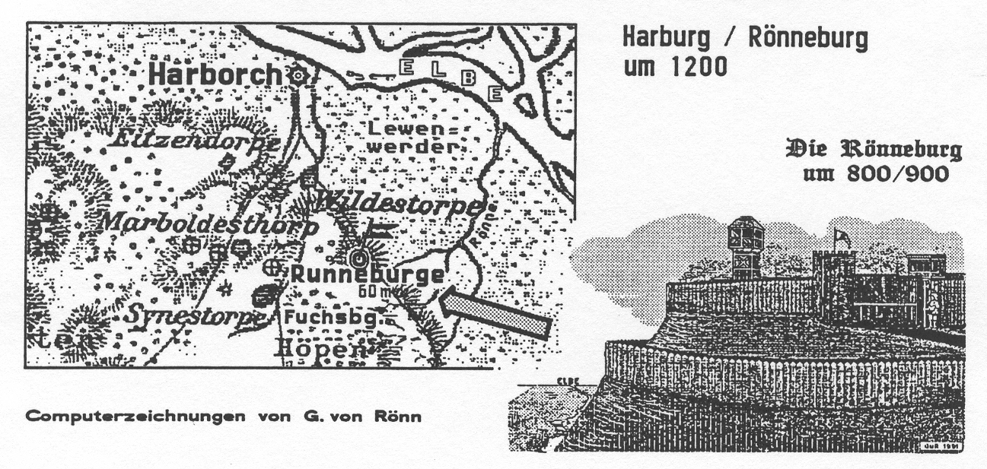
Harburg/Rönneburg
Circa 1200

The Rönneburg
Circa 800/900

Computer illustrations by Gerhard von Rönn

Description of like name locations

Page 162 Rönneburg by Theodor Benecke (1924)
- Rönneburg by Dr. Klaus Richter (1990)
- Rönneburg=Legend by F. Heinicke (1845)
- Rönnau, Large and small=Ronnau, 2 x Rönne
- Rönne on Bornholm, 2 x Rönnbeck
- Ronneburg in Thürigen
- Ronneburg in Hessen, Ronnenberg bei Hannover

About the Rönneburg

In the “Official Lüneburg Documents, Baron von Hodenberg, in 1859, firmly states, that the name of this castle location and of the neighboring Bishopric Bremen, namely at Wiepelnbusch and Coppel, Gogericht Achim and in the parish Osten, may well have been a familial connection to the family von Rönne, who settled here during the 17th century.

Theodor Benecke, Director of the Harburg Museum, wrote in 1924, in the newspaper “Hamburg Tageblatt”, out of which the following is excerpted:

“The first Bishop of Hamburg, Ansgar, also called the Apostle of the North, who was appointed Archbishop of Hamburg by the Normans, to Ramelsloh, where a pious lady named Ikia received him and presensted him a piece of land for the building of a monastery. From here, Ansgar is said to have founded branch chapels in Festeburg (the old Gersedeborg) on the Seeve River and in Sinnsdörpe or Seestorp (the modern Sinstorf) near the “old Ruhnenborgk” (which is Rönneburg) in the Archdiaconate Hiddefelde (now Hittfeld), as derived out of an old document from year 1004. Even then in the 11th century, the Rönneburg was already referred to as an “old” fortress castle.
Ruhnenborgh or Rönneburg means so much as a castle fortress on the Rönne River or Ronnau. This river was, according to an old map, a branch of the Elbe River between Over and Geesthacht (note ‘geest’ denotes high dry ground—important in the easily flooded northern low lands before the time of dikes). From Over to the Geesthöhen, it went throughout Neuland (called Lewenwerder), an area, which even then, was without dikes, a fortress on the “Ronnau”…The locale Over on the Elbe, respectively Ronnau was even then an old, important crossing place, whereby the Rönne, a connection of this ancient trade route was placed.
The Rönneburg was “…was erected for the protection of that particular trade route. To gain the proffered protections, the travelers had to pay a toll. It was also no way a robbers roost, which was already proved from it, that the early settlers under the fortress expected specific protection in promise to take.
In this way, the village Rönneburg came into being. Also herefore lays proof for it”
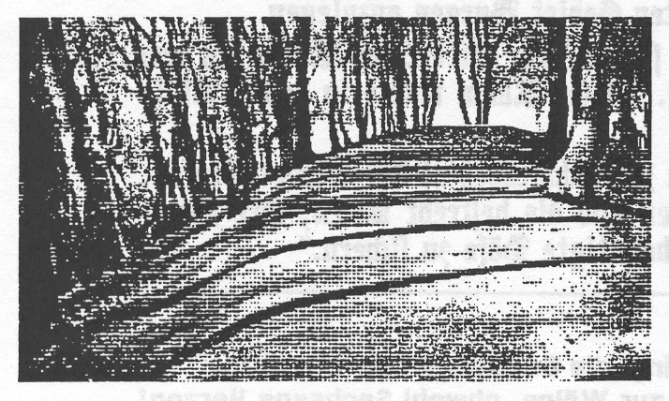
“Some traces of the fortress are not to be found. Yet, today, a meter high earth wall round about over. In the part facing the Elbe River valley, remnants of a second outer wall are recognizable. A foot path, leading along the side of the fortress, is called yet today commonly “Burggraben”. The walls were, in any case, fortified with palisades, thickness on thickness ramroded cut wood.
The gate was, it is thought, to the west, to the dry side, which went over from all sides, steeply ascending castle hill, gradually into the back situated Heigelland.
…As the castle and city Harburg took on more importance, is the “Ruhnenborgk” become gradually unimportant, that the remains were abandoned and finally fell into ruins.
Newer knowledge about this Rönneburg, Dr. Richter, in 1990, describes, since 1973,

responsibly in the Hamburg State Archives for the writing credit in the Harburg room. He mentions in his treatise: “Middle Ages Castles and established Houses in the Harburg Room (see Harburg county calendar 1990) five ancient ringed walled castles”. The castle walls on the east of Hollenstedt, Kakendorf and Bustehude-Neugraben and the castle mountain in Hamburg-Rönneburg.
“Of all those structures to be dealt with here none is so impressive as Rönneburg, rising above the environs located in the midst of like named places directly on the Elbe lowlands. In the north and east, surrounded by abundantly watered swamps, which (the one) above a little brook, the ‘Rönne’, drained hither to the Elbe, this hill fortification offered an extraordinary propitious, strategic site. The knoll of this mountain was made level, a wall surrounding an oval from 80 meter long to 34 meter wide. The access road led from the northeast into the inner space. On the narrow side to the west and east, a familiar dry ditch continued into the steep slope with a wall laid in from for additional protection.”
“Firmly stated”, he writes further, “that in the 15th century, the Duke of Braunschweig-Lüneburg occupied the ownership to the entire four Rönne manors and, thus, at that time developed an uniform estate. From their toporgraphical location, were permitted to take up, that this Rönneburg, equally, served additionaly the village on the Balkenberg, the lower Elbe region to watch over. This was able to assume, that it in the 9th and 10th centuries was built for the defense from the Elbe upstream wayfaring Viking fleets”.
“The Harburg Space, area up to the Seeve River, belonged in the early middle ages to the large region Wigmodien and in the high middle ages to the county Stade. The non-titled region of Harburg found its continuation to the west into the Elbe-Weser-Drejeck, meanwhile the Winsemer area was practically ungoverned territory. For that, there are 3 explanations:
- Demonstrably Wigmodien, the final phase of the Saxon War around 800, by Charlmagne the Great, intregating into the Frankish Empire stronger resistance in opposition as Bardengau eastward to the Seeve River. Hopefully, at the beginning of the 9th century, in Wigmodien, the necessary Frankish power to secure and to locate in the newly conquired villages.
- The Viking invasions between 845 and 994 set right the area on the lower Elbe up to the streams confluence between Hamburg and Harburg. This area must, in the first line of the villages be protected.
- The Harburg district developed from 900 until 1144, a Lord’s area of the Stade Counts, specifically ownership and sovereignty up to the Seeve were designated, their association of Lords through the commoners and service men secured their dwellings.

Notations:

- Count Hartwig at Stade became archbishop and officially established the county.
12 th century Berhard, Alberti Urfi Sohn, named himself Count of Wölpe-Saxon Duke
1205 Count Yso von Wölpe (!) became Bishop of Verden.
1233 Countess Kunigunde von Wölpe and her son, Count Konrad, pledged to the Convent Walsrode the tenth
at “Runneborge” (Lüneburger Document Book, Document 17)
1242 Bishop Lüder at Verden took over the convent Walsrode the legal right to the tenth at “Renneborgh”,
which Colonel Sigfried from Count von Wölpe had purchased
(Lüneberge Document Book, Document 33)
1418 The first original tradition out 1418 has “Ronneborgh”
Die Rönnenburg
A legend from the 15th century by F. Heinecke

When formerly, still in the middle-ages, With strong and fully aroused power
Much robbery and looting far and near The murderer he fights off his neck
By monk and knight was perpetrated, Enraged and full of fury, he seizes
The Rönne castle was not likely touched And bravely beats him to the ground.

Many beggar monks in all the country Then he binds him and drags him away
Were known as holy men, Certainly to the holy place;
Yet underneath their holy robes— To the hut and to the pious man,
Was hidden their killing bat. Who might have further information.

So it went also around the Rönnenburg Who was the vanquished rascal?
There, were nowadays no path leads through The butcher peers into his face;
In a clearing alone she was located Well, well, are you the pious man
In the forest—where daylight did not penetrate In holy frock, capable of doing this?

A hermit, as a holy man, The hermit monk he got his portion
By calling—who could endure piety; The deceiver fell by the executioner’s axe.
If one came to him from near and far, His grave is below the Ravens-Rock,
For one likes to hear the comfort of the pious. Made for such pious ones.

However, many of the local people But in the hut one found also
Were murdered by the robber’s hand. In a hole, the remains of many who were killed
Whoever walked to town by night, And much, very much stolen property,
Here would most likely be done away with. Which was gifted to the nearby monastery.

Not far from where across a foot-bridge Now a quarrel began about this:
The narrow path meets the Lünebergs Road, The Rönnen people(6) who from the pious man
Who passes here, and all alone Had desired their portion—received nothing.
Is in danger of imminent death. “For Priest-Power outweighs anyone”.

Once crossed this way, at early dawn, Now, wanderers who pass this way,
A Harburg butcher who never was See nothing of what took place here.
Afraid of something like this. Time has swept everything away.
Boldly with strength he always walked. Once a chapel adorned the place.

Yet, he had barely crossed the footbridge, And, where the Rönneburg once stood
When he stumbled over a stick in the path, With spires and turrets on the steep wall,
And as he lay, attacked he was, On the hill, she once held her head with pride.
And a battle ensued immediately. Now all that grows there is crooked wood.

(1) From the documents of the “v...schen” assembled.
The butcher, no weak chap was he, (2) Dominican, Augustin, Franziskan and Capuzin
He would not forfeit his life easily. (3) Now is the land forested, with roads and cultivated.
And when he noticed a knife blade glint, (4) This area is now known as “Fuchsberg”
He knew then that death lurked near. (5) Here it was, where Canzler Bessell sometimes at the
Harburg Duke House concentrated on his official duties.

Edited, printed, and published in (6) I. e. Hans and Ulrich von Rönnen, out of the first marriage

October 1845 by C. Hergeröder (HAN) of Eckeberg von Rönnen with Mechthild von Schulenburg.

RÖNNAU (formerly Rennow)
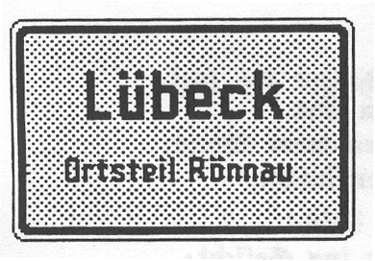
This town Rönnau, located in the Travemunde sector, southwest from Travemunde, and belonged around 1840 to the Johanns Convent in Lübeck. The village had, at that time, 4 full houses and a water mill, and half was sold by Count Gerhard and Johann of Holstein in 1259, and half was sold in 1263 by Otto von Plön to the Johannis Convent.

The Great and the Small Rönnau

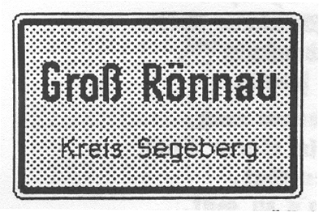
The erstwhile family von Rönne took their name from the Great Rönnau by Segeberg. Already in the year 1238, were the brothers Marquard and Berthold von Rennowe named. This family died out in 1564 with Eiler Rönnau at Hvidkilde. In 1840, Great Rönnau contained 7 full houses, 3 twelve unit houses and 3 cottages with land.
In 1840, of the Little Rönnau, to the authorities of Traventhal belonged 1 full house, 1 2/3 house (triplet), ½ house (duplex) and 6 cottages. To the estate Neutschau belonged 1 full house, 1 sewing house, 4 cottages; to the Hasselburg estate 2 full houses and 2 cottages. The Rönnau water mill belonged, as well, to the Neutschau estate; however, in 1674 was sold because of contested ownership. In 1796, a windmill was erected. Normally, the “Tenth” of this village belonged to the Segeberg Convent

Rönne (suburb of Kiel)
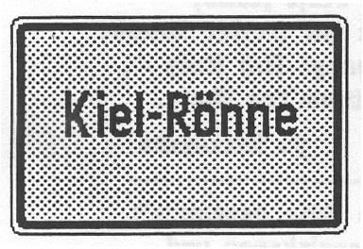
The name of the village, which was in 1970 annexed to the city Kiel, derives undoubtedly from Rönne-ditch, creek, narrow water stream. The medieval form is “Renne”. The village formerly belonged to the property of the monastery Prietz, in Elmschenhagen parish. In 1840, to Rönne, belonged 5 full houses, 1 half-house (duplex) and several cottages.

Rönne (Township Harburg)

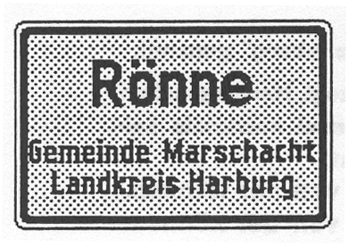
Here, there is ever yet a “Rönne”; i.e. one now equipped with locks, harnessing this contributary to the Elbe River. The name of the village between the Elbe and the Rönne refers, without question, to that Rönne which existed here since ancient time. A connection with the family von Rönne, or to the former “Rönneburg” about 20 kilometers distant does not seem to exist.
All information around the year 1840, of the places Rönnau, Large and Small Rönnau, Rönne (Kiel) are taken from the “Topography of the Dukedom Holstein”, assembled by Johannes von Schröder; printed in 1841 in Oldenberg, Holstein.
Rönne on Bornholm (Denmark)

On the Danish Island of Bornholm in the Baltic Sea, there was a principality Rönne, which after 1149 was in the sole ownership of the Danish King on Bornholm. In the year 1259, his Lilleburg was conquered by Andreas Erlandsen, a brother of the archbishop, and Prince Jaromir von Rügen, and burned to the ground. By excavating, coins were found there, which were out of the time of Christoffer (1252-1259). A further report from this principality is lacking.

Rönne, the harbor and principal place of the island Bornholm, got its name, according to information from the Bornholm Central Library, from the Nordic word “Rothne”, later “Rädden”, in German translated “putrefied or spoiled”; respectively a “clammy place”. The oldest Rönnes were Rönne (runa, rona, rone)-raaden—oldn rottin, so rotten, putrefied, spoiled.

A reference to the generic name Rönne seems not to be present, although the above mentioned designation “Furstentum Ronne” with Lilleburg, could not be made clear. Since the 15th century, there is on Bornholm the family name Rönne, inferred to be a citizen from the town Rönne.
In “Denmarks Gamle Personname”, with the annual census in 1453, is a Claus Ronne registered. In addition to Rennow, one finds several recordings of Rönnow, Ronnowe, Ronnowen.

Rönnebeck (Altmark)

In the year 1290, is a family von Rönnebeck for the first time documented, what was named after the village Rönnebeck. After 1748, the family died out. Kaiser Karl IV, in 1375, permitted for clarification of his ownership ratio and revenues from the Mark Brandenburg, the so called Land Book, to be drawn up, in which also Rönnebeck belonged, as a loaned ownership, to the family von Bartensteben, which from 35 villages of Altmark received their income. This was in 1436, 1473 and 1492 sustained by military governorship, respectively electorally, to the Lords of Bartesteben. In a Land Book, 1781, one reads: “Rönnebeck belonged still in the past century to the von Rönnebeck, after which to von Rintorf, now 3 parts to the heirs of the War Council. In year 1804, the village counted 103 residents, 2 landed estates, 2 houses, 3 1/1 houses and 6 cottages with land and a windmill. The oldest structure of the town is a field stone church built around 1200. In 1842 Rönnebeck parish is with two qualified manorial state parliamentarians, 141 residents, with 18 households. After 1945 the knightly landed estate was divided up.
The castle was, as a symbol of a “feudal past” torn down, what in year 1990 would be lamented universally.

Rönnebeck (Township Gransee)

The new mayor of Rönnebeck, Lord Nettelbeck, was able in 1991 to give no information about the naming of his village. Maybe further discoveries are yet to come in time! Probably but a negative report!!

The Ronneburg in Thürigen

In his “Chronicle of the city and care of Ronneburg”, printed in 1844, homeland researcher C Böhme writes;
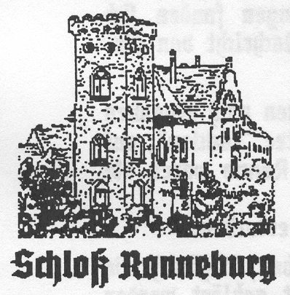
Already in the 10th century, Ronneburg was thought to be an old city and in a document of 1802, was the same mentioned in the history of the governor von Weida. The governor Heinrich I (the Pious) and Heinrich II (the rich man), as, by this time, Lords of the new lands east of the Elbe River, in the financial interests of their houses, would have arranged and guided the Germanization, promoted through building fortified places and encouraging emerging colonial villages, in the same way as developing rural settlements. From the year 1209 stems Ronneburg’s first documented reference.
Under the witnesses of a deed of donation of the Weider Governor appears “Henricus de Ronneberg, Hellvecius plebanus de Ronneberg”. This document attests the existence of a fortified castle and parish at the beginning of the 13th century.”
The early history of Ronneburg, after research, reveals the following results:
1. Around 800, a late Slavic Settlement in todays city area on the Westram of Grenzwal between Geraha
and Plisni.
2. After 900, a German palisadiac military post on the perimeter of the mountain fort.
3. At approximately 1180 was the fortress of the Weidär governor enlarged, to include village suburbs and settlement houses.
4. Between 1150 and 1250 German farmers were in Grenzwald.
5. After 1250, followed the methodical new founding of the city through the Plauen governor, and as documented in 1304-1307 followed a fortification of the city.
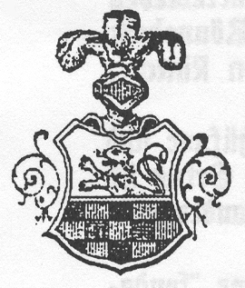
“Lords of the Ronneberg”, were evident at first, first the Governor von Weida, then the Plauen and later the Reussen. In the 15th century, the military governor von Meissen; in the
16th century the von Wildenfels and Schönkirchen; bestowed by the Altenburg dynasty. Before the Weidaer Governors: see above 1 & 2—After the 30 Years War, the varied entitlements to the Ronneburg, for the chronicle, are not interesting. Today, this east Thürigen city (industrial, ancient construction, etc) has over 12,000 residents.
The “Cultural Center Castle” in Ronneburg, he writes in January 1991: “The name ‘Ronneburg’ in its emergence has become to mean differently. Was chosen among others the interpretation “Rone” Family Tree or after the god “Rone”. In treatises at the beginning of our century, one found also the interpretation ‘castle on the Talmulde’, which in ancient time also were designated as Rune, Rünne, Rinne or Ronne”.

The family name Ronneburger will be or can be only connected with the above mentioned place.

Result for the family von Rönne “no connection”—negative result.
The Ronneburg in Hesse

A description of the Wetterau in Hesse, in the year 1747, mentions 57 castles. Out of these many former residences of nobility, looms the Ronneburg, a steep rounded mountain top as a landmark. Thick walls and narrow steps, halls where knights feasted, armament and swords: which is the village museum today. From the 13th century, a fountain in the outer court, walled of square sand stones 100 meter deep. From Bergfried one looks out over the ways and roads of the Wetterau, which in the 14th century, which as robbers the Lords von Cronberg made use of, controlling and looting wandering merchants of their “valuable pepper sacks”, who did not offer tribute to the Lords.
From 1736, Nicholaus Ludwig, Count of Zinzendorf, lived at the mountain fortress, who due to spreading false doctrimes, was corrupted by the Saxon King Friedrich August of the land. Count Ernst Easimir had already in 1712 progmulgated an Edict of Tolerance for Ronneburg.

Ronnenburg by Hannover
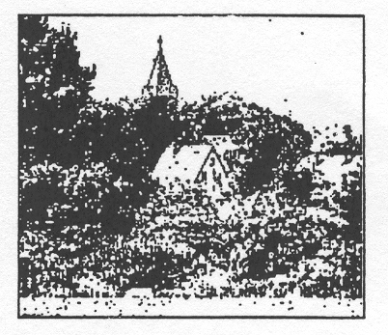
South of Hannover is located the village Ronnenberg, since decades was known far across the borders as a prominent wholesale vegetable truck gardner. According to the understanding of the homeland association, Ronnenberg is
one of the oldest settlements in all of north Germany. Ronnenberg is of old German origin. The Ronnenberg has a hill about 25 meter high and was once “The Thing”--and place of jurisdiction and of providential consultation; the Runen Interrogation; from the name “Runibergum”. Already in 530 A. D. the place was mentioned in documents, for here two highways cross, old trade routes, in extending Roman roads from the Rhein to the east and the northeast. The East-west highway, which lay between the Nordrand of Deisterge and the Steinhuder Sea, Drusus already in year 11 B. C., was permitted to take, as he moved to the Elbe and paused to stop by todays Magdeburg.
This highway, also around 530 A. D., saw the united Frankish Army by their King Theuderich move to the east. In the swampish depressions by the village Runibergum, today’s Ronnenberg, the Thüringens under King Irminfried trampled upon it. After a 3 day dreadful cavalry battle, was the battle to the credit of the Franks decided.

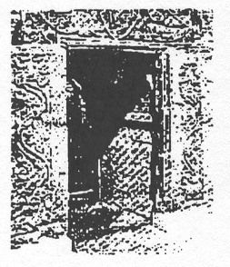
Kaiser Karl the Great had here, around 800, in the movement of Christianizing and to the honor of Bonifatius erected a chapel; specifically, today stone remnants of the portal are to be seen (see left). In 1031, Count Wederkind I, had a judicial court in Runibergum. In 1346, Henrick, Ludeler and Evert sold their last property to the church of Ronnenberg. The coat of arms of the barons house is for today’s city definite.

Result for the Family von Rönne: No connection—negative report.

